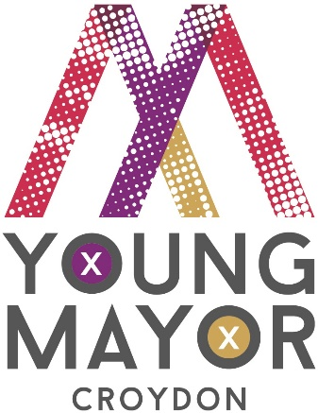
Croydon Young Mayor and Deputy Young Mayor
booking form
William Awomoyi and Shea Williams
April 2018 - March 2019

The Croydon Young Mayor is elected to represent the views of young people and encourage them to create opportunities around issues that matter to them and their communities.
The Young Mayor and Deputy are able to visit groups and organisations and to talk with young people about their concerns and ideas for the borough of Croydon.
If you would like to propose an invite or suggestion of an event or meeting to the Young Mayor and Deputy please complete this booking form and return it to youngmayor@croydon.gov.uk no later than two weeks in advance of the date of your event/meeting.
Sometimes the Young Mayor and Deputy may be busy so we can offer the invite to members of Croydon Youth Cabinet who also represent the views of young people in Croydon, if you are happy to accept them please indicate below.

Date of event:

Title/purpose of event:

Organisation:

Evidence of safeguarding procedures and DBS checks for staff: |  | (due to the age of the Young Mayor and Deputy)
Enhanced DBS No |  |  |  |  |  |  | Enhanced DBS Expiry
Public Liability Insurance details
Do you need a member of staff or parent/carer to attend? |  | Yes ⃝ |  | No ⃝
Venue/address including postcode:
Time event begins: |  |  |  |  |  | the Young Mayor should arrive at:
Time event ends: |  |  |  |  |  | and will be free to leave at:
Name and title of person(s) who will greet the Young Mayor on arrival:
Name(s) of other VIPs and local Cllrs/politicians attending:
Please provide a brief overview of what the Young Mayor and/or Deputy will be expected to do
Will you taking video or photographic recordings of this event for publicity purposes?  (Please tick box) |  | YES ⃝ | NO ⃝
If you answered yes to the above please state to which publication, website, social media handle you intend to publish these recordings
Will refreshments be served?  (Please tick box) |  | YES ⃝ | NO ⃝
Are you happy to have members of the Youth Cabinet attend in the Young Mayor and Deputy’s absence? |  |  |  |  | Yes ⃝ |  |  |  |  | No ⃝
Please give details of the person with whom the Youth Engagement team should liaise when discussing arrangements for this event
Name: |  |  |  |  |  | Address:
Telephone number:

Email:

