

**Neighbourhood Safety Service**

**Body Worn CCTV Cameras**

**Policy [Public Access]**

**V1.0**

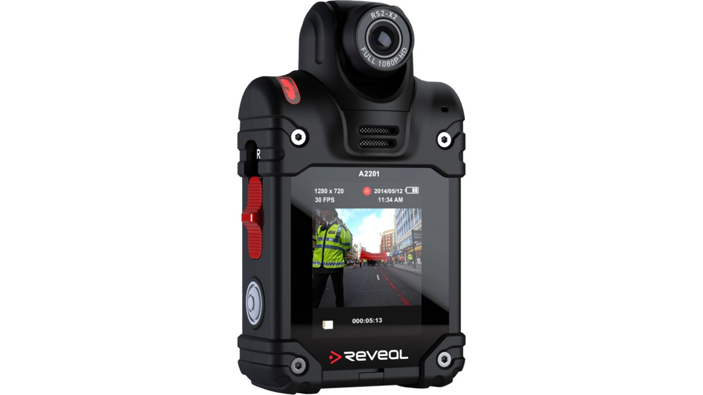

# Introduction

## This document sets out Croydon Council’s Policy Guidelines for the use of Body Worn Video (BWV) cameras by the Environmental Enforcement and Neighbourhood Safety Teams . It will enable employees to comply with the relevant legislation relating to video recording and outline the associated benefits. It also documents best practice procedures with regard to integrity of data, images and video as well as its security and use.

## BWV cameras provide an independent record of events as they happen and act as a deterrent to would be offenders. Footage gathered by BWV cameras will provide irrefutable evidence of criminal or unacceptable civil activity and help convict those who offend or deter those who may act in physically or verbally abusive manner

## BWV forms part of an employees Personal Protective Equipment. It will always be used in an overt manner and usage will emphasized by Environmental Enforcement and Neighbourhood Safety Officers by giving a clear verbal instruction that recording is taking place.

# What is Body Worn Video Equipment?

## Any style of camera deployed by Croydon Council Officers which is carried or fixed to their uniform and is capable of capturing both video and audio information collectively falls under the category of BWV Equipment.

## Advancing technology has meant that BWV has become smaller, lighter, more easily carried and have far greater capabilities in when and where they can be used. In addition, the actual quality of the captured data is of a high standard.

## The devices themselves are generally mounted on the torso of an employee and will be easily identifiable as a CCTV camera.

# Why use Body Worn Video Equipment?

## Croydon Council has a responsibility to, uphold Community Safety and Environmental Enforcement issues, investigate anti-social behaviour issues (ASB); to protect members of the public and their property, and prevent, detect and investigate crime. This often involves stopping and speaking to the public and Officers recording information in their pocket Books (PBs). In some instances, what has been recorded in a Pocket Book has been the subject of interpretation and the subject of debate. Equally it may not have presented the best possible primary evidence to support a prosecution.

## By utilising BWV Equipment,Officers are able to record exactly what happened, what was said and when, in an indisputable format. BWV use will be at the discretion of Officers and should be:

* Incident specific
* Proportionate
* Legitimate
* Necessary, and
* Justifiable.

## BWV is complementary to any entry being made in the Pocket Book and is not a replacement for it.

# Pressing Need

## Body Worn Video (BWV) will be used by the Environmental Enforcement and Neighbourhood Safety Teams for the following purposes:-

* The prevention and detection of crime, through the gathering of intelligence including use of images and sound as evidence in criminal and or civil proceedings.
* Reduce incidences of public disorder.
* Present evidence to support London Borough of Croydon’s procedures.
* Address issues associated with staff practices.
* Identification of training needs.

## BWV equipment is capable of capturing primary evidence in such a way that it is able to bring a compelling and an indisputable account of the circumstances at that time. This will not replace the needs to capture other types of evidence but will go a considerable way in reducing any ambiguities and should be considered as an additional aid.

## BWV equipment will not be routinely recording and monitoring all activity on a continuous basis. To do so would fundamentally breach the privacy of law abiding members of the public, who are going about their legitimate lives, as well as the privacy of Officers going about their work. This cannot be justifiable from the perspective of proportionality and legitimacy.

## The BWV equipment employed by Croydon Council is incapable of operating in such a way principally due to a lack of suitable battery life. In addition, such a practice would require the storing, reviewing and then disposal of large quantities of data.

## The use of BWV equipment will be primarily driven by the incidents and circumstances presented to Officers or in anticipation of responding to a reported and unfolding incident, or when exercising a specific legal power.

## Croydon Council has issued Officers with cards, as below explaining the use of BWV. These are handed to customers who raise queries regarding BWV and advise how the Councils policies may be accessed.

Croydon Logo 2016

Our Officers use Body Worn Video Devices with video and audio recording capability.

Our policies can be accessed as follows

Email: CCTV@croydon.gov.uk

Web: www.croydon.gov.uk/CCTV

Tel: 020 8726 6000

## Any material required to support an on-going investigation or prosecution, or provide evidence for intelligence purposes, or settle complaints against Officers will be retained and be processed under Croydon Council procedures for dealing with Public Space Surveillance (PSS) evidence in accordance with the Police & Criminal Evidence Act 1984 as well as the Criminal Procedures Investigations Act 1996 (CPIA). All material not required will be automatically erased after 28 days. In normal circumstances any information captured and used in evidence as part of the prosecution of an offender will be kept of 6 years from the completion of any judicial process, this is to allow the evidence to be available for any subsequent appeal by the defendant.

## Any request to view captured video by a member of the public, will need to be made in writing to Croydon in line with the ‘subject access procedure’. Evidence of identity prior to viewing must also be provided.

# Regulation of BWV Equipment

## The use of BWV Equipment is subject to compliance with the Surveillance camera code of practice which is produced by the Information Commissioner. The code is influenced by the Protection of Freedom Act (“POFA”). It is designed to sit alongside the POFA’s own surveillance camera code. The harmonised approach is furthered by a memorandum of understanding between the Information Commissioner and the Surveillance Commissioner.

## The code of practice sets out principles which encapsulates:

* Data Protection Act 1998
* Freedom of Information Act 2000
* Human Rights Act 1998
* Protection of Freedoms Act 2012

## The use by local authorities of BWV Equipment must be shown to be proportionate, legitimate, necessary and justifiable. In addition, use of the equipment should address a ‘pressing social need’ especially in respect of its application within the confines of the Articles enshrined by the European Convention of Human Rights within the Human Rights Act 1998. This next section explains the various aspects of the legislation and guidance that covers this equipment, and how Croydon Council wil ensure that the rights and privacy of the public are balanced against the law.

**European Convention of Human Rights Act 1998**

For the purposes of the European Convention of Human Rights (ECHR) and the Human Rights Act 1998, it has been determined that it is lawful to use image gathering equipment such as cameras in common law as above *(Wood v Commissioner of Police for the Metropolis* [2009] and *Murray v the UK [1995]*), however use of BWV equipment is viewed as ‘an interference’1 and must always be justifiable. Therefore any actions by Council Officers must have a legitimate aim and the use of this equipment must be shown to be proportionate to achieving this.

Under this legislation a number of ‘Articles’, protect the rights of citizens. Some of these Articles are absolute whereas others are ‘qualified’ and any interference with these is limited.

Interference with qualified rights is permissible only if:

* There is a clear legal basis for the interference with the qualified right that people can find out and understand, and
* The Action/interference seeks to achieve a legitimate aim.
* Legitimate aims are set out in each article containing a qualified right and they vary from article to article, they include for example, the interests of National Security, the prevention and detection of crime and public safety. Any interference with one of the rights contained in articles 8 -11 must fall under one of the permitted aims set out in the relevant article.
* The action is necessary in a democratic society. This means that the action or interference must be in response to a pressing social need and should be assessed by demonstrating evidence of a level of severity or immediacy/unpredictability, and alternatives should have been reviewed.

1 Ben Jaffey QC December 2013

**Article 8 of the ECHR is the right to respect for private and family life, home and correspondence**

Under the legislation this article is a qualified right and authorities are required to consider this article when dealing with recorded images, whether they are made in public or private areas. Accordingly, this assessment looks to address the issues raised by this Article and introduces suitable safeguards, associated with how Croydon Council deploys this equipment, in both the public and private arenas, and then how it deals with the product from any use. Throughout, the principle objective is ensuring that any interference with the rights of parties can only be justified if it is:

* **Necessary**
* **In pursuit of a legitimate aim** – such as the prevention, investigation and detection of crime, with the necessity test being satisfied by the presence of a pressing social need.
* **In accordance with the law** - legal advice has been sought to establish that BWV equipment is in accordance of the law.

**Article 6 of the ECHR provides for the right to a fair trial**

All images from BWV equipment have the potential for use in court proceedings whether they provide information that is beneficial to the prosecution or defence. The information will be safeguarded by an audit trail in the same way as other evidence that is retained for court.

It must be emphasised that BWV equipment can collect valuable evidence for use in criminal prosecutions, ensure that the local authority acts with integrity and transparency and potentially provides objective evidence of controversial events. It offers protection for both citizens and the local authority. However this justification may be closely scrutinised by a court and it is essential that BWV equipment recordings will not retained where there is no clear evidence of an offence, unless some other good reason exists for their retention.

Recordings of persons in a public place are only public for those present at the time, so those situations are therefore still regarded as potentially private (R v Brentwood Borough Council ex parte Peck [2003])2. Recorded conversations between members of the public should always be considered private.

Users of BWCE must consider Article 8 when recording and must not record beyond what is necessary.

**Data Protection Act 1998 and General Data Protection Regulation (GDPR)**

The Data Protection Act 1998 (DPA) and the new legislation General Data Protection Regulation (GDPR) is legislation that regulates the processing of personal data including sensitive personal data, whether processed on a computer, pss, still images on a camera or any other media. Any recorded image and audio recording from any device, which includes BWCE, that can identify a particular person or learning about their activities, is described as personal data and is covered by the DPA and GDPR and in particular within the principles contained within, a full list of which are included as an appendix;

Principle 1 of the DPA & GDPR (fair and lawful processing) requires that the data subject must be informed of:

* The identity of the data controller
* The purpose or purposes for which the material is intended to be processed and
* Any further information that is necessary for processing to be fair

Croydon Council has the responsibility for controlling this information and is known as the Data Controller for information captured and used within its area, for a community safety purpose. If required, Officers using BWV equipment must be prepared to explain how the capture and processing of any data is compliant with the legal obligations imposed under this Act. However, Croydon Council has clearly identified the BWV equipment under its control. Therefore, as a general rule, where Officers are in uniform and are clearly carrying or wearing a suitably identified camera this condition would be considered to have been satisfied.

In order for Croydon Council to ensure compliance with the DPA & GDPR, the following has been undertaken:-

* A local media campaign to advertise the use of BWV equipment, using local newspapers and other media, and the council website
* Advised the local community-based forums of the use of this technology
* Ensure users where possible/practicable announce to the subject(s) of an encounter that video and audio recording is taking place using BWV equipment
* The sharing of BWV equipment images with other agencies and the media, and any images will only occur in accordance with the requirements of the Data Protection Act 1998 and GDPR.

**Criminal Procedure and Investigations Act 1996**

The Criminal Procedure and Investigations Act 1996 (CPIA) introduced the statutory test for disclosure of material to the defence in criminal cases.

Croydon Council is able to disclose both used and un-used images and demonstrate that this has been done. Deletion of any recorded images (or a third party’s images in their possession) prior to their respective retention periods, may amount to a breach of the Act if they are not then available for disclosure. Images that are relevant to an investigation must be retained in accordance with the Code of Practice issued under Section 23 of the CPIA.

**Freedom of Information Act 2000**

The Freedom of Information Act 2000 grants a general right of access to all types of recorded information held by public authorities, which includes digital images recorded by BWV equipment

The Act does however provide some specific exemptions to the requirements to disclose information; each application is dealt with on a case-by-case basis.

**Protection of Freedoms Act 2012 & the Surveillance Camera Code of Practice**

Part 2 of the Protection of Freedoms Act 2012 deals with the regulation of PSS and other surveillance camera technology and introduces the Code of Practice for Surveillance Camera systems. Section 29(6) of the act provides that this code covers “any other systems for recording or viewing visual images for surveillance purposes”. This would include BWV equipment.

Croydon Council adheres to this code as its content will be relevant when a court is considering whether the use of BWV equipment:-

* Complies with the first Data Protection Principle;
* Is prescribed by law for the purposes of Article 8 ECHR; and
* Is a proportionate interference with Convention rights under Article 8(2) ECHR?

-Ends-