Collated reports Croydon Mobility Forum – 8 June 2016
LONDON DIAL-A-RIDE
CROYDON PERFORMANCE
Full year
(1 April – 31 March)

 | 2014/15 | 2015/16 | change
Requests | 76,997 | 72,764 | -5.5%
% requests scheduled | 87.8% | 88.3% | +0.5
Passenger cancellations | 14.9% | 14.1% | 0.8
Completed journeys | 57,475 | 55,136 | -4.1%
Performance overview:
Compared to 2014/15, demand for Dial-a-Ride in Croydon fell by over 5% in 2015/16. However, the number of completed trips did not fall so significantly due to an improvement in the proportion of requests scheduled and a reduced passenger cancellation rate.
Updates on service improvements
Dial-a-Ride continue with their recruitment and training of new drivers, with the second group of drivers this year now in their final week of classroom based training and due to go out to their depots for two weeks on the job training next week.
The review of Dial-a-Ride policy on longer distance journeys is still ongoing and we are currently analysing the feedback already received from customers. We are also looking at analysing how any proposed changes to our existing policy would impact on the majority of customers, who request local journeys. We will provide a further update in the autumn.
Dial-a-Ride has also amended its Terms and Conditions of carriage in respect of people with a diagnosis of dementia so that there is a possibility, with certain safeguards in place, that some people may be able to travel without an essential escort whilst their symptoms remain mild. We are currently running the change in policy as a pilot – please contact Passenger Services if you are aware of anyone who would like to join the pilot.
Finally, Dial-a-Ride is currently reviewing the information literature it produces about the service and would welcome any comments from Forum members for improvements in this area.

Travel service report for Mobility Forum June 2016

Blue Badges
Unfortunately the individual who had previously set up scam BB application sites is back in business. Google have acted ethically upon the request from Department for Transport and refused to have a link to the scam site. However this has not stopped other providers of search engines from accepting the scammer’s fee for advertising his site. We have been alerted that if you search for “Blue Badge” on Bing the scam site appears above the official site and it may be that other lesser used search sites have been approached by the scammer. Department for Transport are working on having these scam sites closed down again but in the meantime please be aware that applications should be made only from the official site www.gov.uk/apply-blue-badge and that you will not be asked to pay a £49 “handling fee” on the official site.
Freedom Passes
London Councils have reported that due to the success of the 2015 and 2016 card reissues where the exercises came in under budget (because so many residents took the option to renew online) that they had sufficient funds left in their reserve fund to waive their management fee for Freedom Passes 2016-2017. This has meant a saving to our council of £8,674 so thank you again to everyone who either renewed online themselves or helped or encouraged some else to do so.
There are no passes bearing the expiry date 31 March 2017, so the next reissue will be 31 March 2018. This doesn’t mean that we all get a year off, however! Instead we will be continuing to check the accuracy of London Councils database and starting the background checks for the 2018 reissue. We will also be working together with London Councils to develop and test a new portal to be used for new Freedom Pass applications from disabled residents.
Taxicard
The membership remains fairly static and our projected spend is likely to be within the allotted budget for the financial year.

Croydon Mobility Forum - 08 June 2016 – GTR update

East Croydon Platform work
Work progressing well to reduce the step height at East Croydon Platforms 1&2 (28 week programme). Completion due 30/09/16.

Industrial Action Updates
As per update below, we plan to evolve many conductor roles and all revenue protection roles to an ‘on-board supervisor’ role, which would focus on helping passengers with service information, checking tickets and offering assistance to passengers who most need it. On modern rolling stock, the evolved role would not close the doors, a responsibility which can transfer from conductors to the driver, aided by modern CCTV providing drivers with a clear view of the doors. On-board supervisors will therefore be freed up to spend more time on customer service on our trains.
Unfortunately, the RMT union began industrial action as it opposes our plans to introduce an on-board supervisor role. We believe the role will be better for passengers, with more time to assist, delivering greater levels of customer service. We have confirmed that there will still be a job for all who want one and conductors will not lose any pay from these changes.
There were two strike days in April and another on 18 May. We would like the RMT to return to meaningful talks, and we continue to believe that the RMT strike action is unnecessary. We have urged the trade union to return to the negotiating table with us and resist further strike action that will cause significant disruption for our passengers.
There are no further strike dates planned at time of writing, though I will ask my colleagues in stakeholder relations to add you to their database so that you are alerted to any changes to this, unless you would prefer not to – please just let me know if so.

More help at hand at our busier stations
We know it’s important for our staff to be more accessible, which is why we want to improve the customer experience and make things easier for you at some of our busier stations.
Our plan is to make our staff more visible and available to everyone using the station by bringing them out from the ticket office and on to the station concourse as Station Hosts.
Our Station Hosts will be there to offer assistance, advice and help you buy the tickets you need, all from the station concourse rather than behind the ticket office.
To help you feel more secure, these stations will be staffed from the very first to last train, seven days a week.
Our plans will also mean that station facilities such as waiting rooms, toilets and lifts will be open for longer, giving you access to facilities you’ve told us are important to you for longer than they are available today.
We’ll ensure Station Hosts receive sufficient training and tools to assist you:
• Hosts will receive Disability Awareness and ramp deployment training
• Hosts will be easily identifiable on the station concourse. At most locations they will operate from easily identified ‘Host Information Points’ within the station concourse area
• Hosts will be proactive in assisting passengers with disabilities
• Induction loops will be provided at appropriate locations, for example, near to Host Information Points
• Protocols will be in place to ensure that the Hosts will prioritise assisting disabled passengers.
• Where applicable, platform staff will continue to deploy ramps as at present (as they are unaffected by these proposed changes). We’ll also ensure there are clear lines of communication exist between the Hosts and platform staff.

More help on board our trains
We want our on board staff to be more visible and available to passengers on our trains, so we want to evolve the conductor role into one of an ‘On-Board Supervisor’ (OBS) on our more modern trains.
The OBS would be more visible to more passengers, travelling on more parts of the network, delivering high-quality customer service and checking tickets. There would be as many trains running with staff on board as they do now, but OBSs will be more visible than they are now because they will have more time and opportunity to offer customer service.
Currently, conductors on our more modern trains have to be in certain parts of the train to close the doors and this sometimes interrupts their time with passengers. On our more modern trains, there is no need for the conductor to close the doors as the driver is able to operate the doors aided by modern CCTV systems, which gives them a clear view of every door on the train.
Whilst conductors will continue to operate on certain services (primarily on older trains where they are needed to operate the doors), the introduction of the OBS role on many services will provide a greater focus on passengers during the journey as the OBSs will not be involved in opening/closing doors.
OBSs will receive training to help to expand the customer service element of their role to provide you with a better experience when travelling with us.
They will also receive Disability Awareness and ramp deployment training, so in addition to platform staff (who will continue to deploy ramps as at present) they will also be able to provide assistance getting on and off trains to those passengers who need it.
We believe our plans will improve the customer experience on board out trains, however we will be continuing to engage on our proposals with key stakeholders including London Travel Watch and Transport Focus.
Reedham Station
Project is underway for provision of step free access to London bound platform (platform 1) at Reedham by re opening the old step free path. Completion due by March 2017 – further details and programme to follow.
December 2018 Timetable
Consultation regarding the December 2018 timetable (linked to completion to Thameslink Programme) due Summer 2016. further details to follow.
Antony Merlyn
Accessibility Manager, GTR
07890 53342

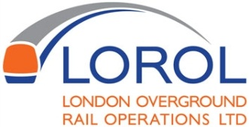
Report to Croydon Mobility Forum
23 March 2016

Introduction
LOROL operates the services which operate from West Croydon and Norwood Junction towards Dalston Junction and Highbury & Islington.

Performance

 | PPM
 | ELL | RIGHT TIME | PERIOD TARGET | NETWORK
Period 2 Result | 93.76% | 70.17% | 95.50% | 94.30%
MAA | 93.77% |  | - | 94.59%

The East London line delivered a period result of 93.76%, which is disappointing following recent signs of improvement on the route. The MAA declined slightly to 93.77%. The largest causes of PPM failures were a points failure at New Cross Gate on 7th May, which caused 62 PPM failures, and a power trip in the Thames Tunnel on 10th May which caused 44 PPM failures.
Network Rail continues to severely impact our operation with 693 PPM failures attributed to infrastructure faults, up from 518 the previous period. 296 PPM failures were attributed to Network Rail Operations.
We continue to work with Thameslink, Southern and Network Rail to reduce these delays. LOROL has now devised an Internal Improvement plan which looks at the relationship with Network Rail, other TOCs and internal factors such as managing illness to passengers on board.

Gospel Oak to Barking Electrification
The first phase of closure on the Gospel Oak to Barking Electrification began on June 4. This is part of an improvement plan and will enable new longer trains to run on the line from 2018. During this phase of works from 4 June to 23 September 2016 there will be no service between South Tottenham and Barking. A Rail Replacement Bus Service will run.

Turn Up and Go
In Period 2, we saw the highest ever number of Turn Up and Go customers using our service, a 49% increase compared to the same time last year with over 1800 assisted during the period.

Improvements in 2016
Following feedback from the forum as well as from other passengers, we have now installed an additional manual release gate operator button for the West Croydon accessible access to platforms 1 and 3. The gate can now be monitored by our platform and ticket office staff, to improve the service to customers needing to use this point of accessibility.

All staff are now undergoing an ill passenger training course to improve the way we deal with passengers who have taken ill on our service. This is to ensure that the passenger can be attended to whilst still ensuring that we still continue to provide a service to the rest of our passenger.

Upcoming Line Closures
Sat 18 Jun to Sun 19 Jun - Surrey Quays to New Cross
Sat 25 Jun– Surrey Quays to New Cross
Sun 26 Jun New Cross Gate to West Croydon and Highbury & Islington to Shadwell
Mon 27 Jun to Thurs 30 Jun – New Cross Gate to Crystal Palace/West Croydon from 23:00 hrs

This Year – New operator announcement

The new operator for London Overground will be Arriva Rail London who will take over operations of the network from 13 November 2016.

Kai-Nneka Townsend
Stakeholder & Community Manager
London Overground Rail Operations Ltd.

London Trams
Report to Mobility Forum – June 8th 2016
One again, a busy time for London Trams as we continue to work to make travelling by tram easy and convenient, particularly if you have an additional mobility need.
“Beckenham Jcn” is the new Beckenham Junction

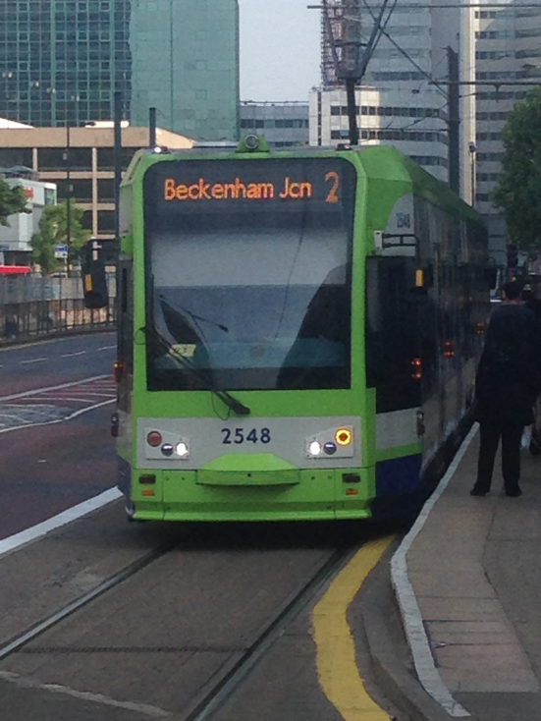
Following feedback from Mobility Forum members on the small size of the front of tram destination for Line 2 services, we have re-configured the destination wording for Beckenham Junction trams allowing the use of a larger font by abbreviating Junction to “Jcn”.

New Interior Display Trial

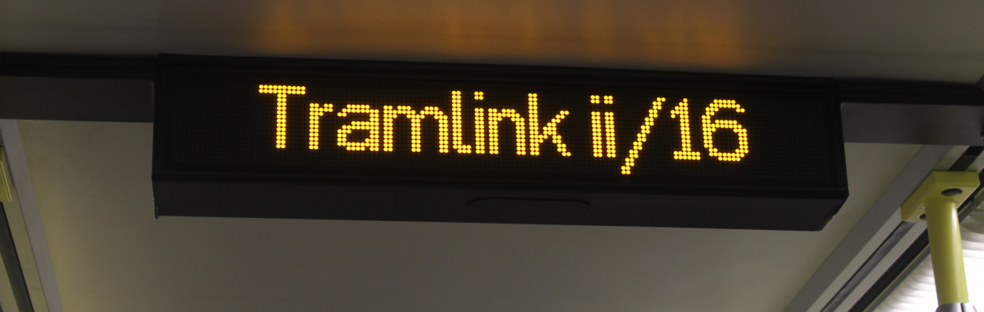

We are testing use of new interior information displays on one tram. These new displays should be easier to read and also include a new additional sign above the cab door.

Any feedback on these new items of equipment would be much appreciated !

New Tram Map.

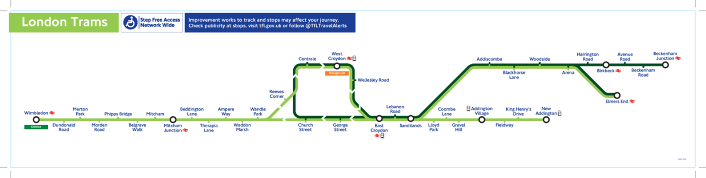

We have made two important changes to the Tram Map, following the extension of Line 4 services to Wimbledon, following feedback form users.

- We have improved the contrast between the routes that only run to through the town centre, and those that run through.

- We now show that there is “Step Free Access Network Wide”.

The tram map is also now to be shown on TfL’s tube map, showing trams as part of the fully integrated transport network in London.

New Platform Passenger Information Displays.

We are in the process of upgrading the Passenger Information Displays at the tram stops, this will allow us to show three lines of tram destination information, and have a display on both sides of the sign.

Because the old signs only displayed in capitals, we have had to retain the old software as we rolled out the new signs, which currently display only capital letters.

When we have installed the last few signs, we will upgrade the software so that lower case letters can be shown, and we will also be including a clock at the bottom of the display.

Nick Baker
Head of Customer Services
London Trams

Nickbaker01@tfl.gov.uk

