

**Good Shepherd Catholic**

**Primary & Nursery School**

**ADMISSIONS POLICY AND PROCEDURES**

**Reviewed September 2024**

**For entry September 2026**

Good Shepherd Catholic Primary and Nursery School is a voluntary aided school in the Diocese of Southwark. It is in the trusteeship of the Diocese. The school is conducted by its governing body as part of the Catholic Church in accordance with its Trust Deed and Instrument of Government and seeks at all times to be a witness to Jesus Christ. The school exists primarily to serve the Catholic community and Catholic children always have priority of admission. However, the Governing Body also welcomes applications from those of other denominations and faiths and from those who have no faith who support the religious ethos of the school.

Having consulted with the Local Authority, the Diocese and other admission authorities, the governors intend to admit into the reception class, in September 2026, up to 30 pupils, the published admission number (PAN), without reference to ability or aptitude.

**Admissions Criteria**

Where the number of applications exceeds 30 the Governors will offer places using the following criteria in the order stated below: -

1. Looked after Catholic children or looked after children in the care of Catholic families and previously looked after Catholic children who have been adopted or who have become the subject of a residence or guardianship order. This includes those children who appear to have been in state care outside of England and ceased to be in state care as a result of being adopted.

2. Catholic children: baptismal certificate or evidence of reception into the Catholic Church must accompany the Certificate of Catholic Practice.

3. Other looked after children and other previously looked after children who have been adopted or who have become the subject of a residence or guardianship order.

4. Children enrolled in the catechumenate. Evidence of enrolment in the catechumenate will be required.

5. Children who are members of Eastern Orthodox Churches. Evidence of Baptism will be required. The Certificate of Religious Practice must be completed.

6. Children of families who are members of other Christian denominations that are part of Churches Together in England or the Evangelical Alliance. Evidence of Baptism (or dedication) provided by a priest or minister of a designated place of worship will be required. The Certificate of Religious Practice must be completed.

7. Children who are members of other Christian denominations. Evidence of Baptism, dedication or membership of the church provided by a priest or minister of a designated place of worship will be required. The Certificate of Religious Practice must be completed.

8. Children who are members of other faiths. Evidence of membership of the faith provided by a religious leader of a designated place of worship will be required. The Certificate of Religious Practice must be completed.

9. Any other children.

**Oversubscription Criteria**

The following order of priorities will be applied when applications within any of the above categories exceed the places available and it is necessary to decide between applications.

i. A brother or sister on the school roll at the time of admission. Evidence of the relationship may be required. The governors will, where logistically possible, admit twins and all siblings from multiple births where one of the children is the last child ranked within the school’s published admissions number.

ii Children of (teaching) staff where the member of staff has been employed at the school for two or more years at the time at which the application for admission to the school is made.

iii Social, pastoral and medical needs which make the school particularly suitable for the child in question. Strong and relevant evidence must be provided, at the time of application, by an appropriate professional authority (e.g. qualified medical practitioner, education welfare officer, social worker or priest).

iv Proximity to the school of the child’s home address, the distance measured in a straight line from the school entrance by the local authority using a geographical computerised information system. Evidence of residence may be required. Where the last remaining place is to be allocated and two or more children are deemed to live at the same distance from the school the place will be decided by the drawing of lots.

**Notes:**

a. Catholics include members of the Ordinariate and the Latin and Oriental Rite Churches that are in union with the Bishop of Rome. Reference to other Christian denominations refers to denominations that are full members of Churches Together in England.

b. A “brother or sister” means children who live as brother and sister including natural brothers or sisters, adopted siblings, stepbrothers or sisters and foster brothers or sisters. It would not include other relatives (e.g. cousins).

c. Home refers to the permanent home address at which the child lives for the majority of his/her time and with the parent who is in receipt of child benefit.

d. A looked after child has the same meaning as in section 22(1) of the Children Act 1989 that is a child who is (a) in the care of a local authority or (b) being provided with accommodation by them in the exercise of their social services functions (e.g. children with foster parents) at the time of making application. A previously looked after child is a child who was looked after but ceased to be so because they were adopted or became subject to a child arrangement order or special guardianship order.

**Admissions procedure**

In addition to the Common Application Form (CAF) required by the Local Authority and school application form, the Certificate of Catholic Practice should be submitted to the school by all Catholic applicants not later than 15th January 2026. Those from a different denomination or faith should complete the Certificate of Religious Practice.

The Certificate of Catholic Practice or Certificate of Religious Practice is not mandatory and is only required for those applying under Criteria 1,2, 4, 5, 6, 7 or 8 of the policy.

Offers of places will be sent to parents by their local authority on the common offer date of 16th April 2026.

Please note that the following forms are available from the school office:

* School application form
* Certificate of Catholic Practice
* Certificate of Religious Practice

**Pupils with an Education Health and Care Plan**

The admission of Children with an Education Health Care Plan is dealt with by a completely separate procedure. The procedure is integral to the making and maintaining of Education Health Care Plan by the pupil’s home local authority. Details of this separate procedure are set out in the SEND code of practice. Children with an Education Health and Care Plan naming the school will be admitted without reference to the above criteria.

**Appeals**

You will be sent a letter with the decision about your application. If your child is refused a place, you can appeal against the decision, in writing, within 25 school days from the date on the decision letter.

You must appeal against each rejection separately. You can only appeal once against each rejection.

In Reception, Year 1 and Year 2, the class size is limited to 30. Your application can be turned down if all the classes already have 30 children.

Your appeal could be successful if:

* Giving your child a place will not increase the class size above the limit
* The admission arrangements have not been properly followed
* The admission criteria do not comply with the school admissions code

**Admission of pupils from Good Shepherd Nursery**

Pupils in Good Shepherd Nursery do not have a right to a place in Reception and a separate application must be made.

**Admission of children below compulsory school age**

The governors will provide for the admission of all children in the September following their fourth birthday. Parents can request that the date their child is admitted to the school is deferred until later in the school year or until the child reaches compulsory school age in that school year; parents may also request that their child attends part-time until the child reaches compulsory school age.

**Admission of children outside their normal age group**

Parents who are seeking a place for their child outside of their normal age group, e.g. the child has experienced problems such as ill health or the parents of a summer born child preferring not to send their child to school until the September following their fifth birthday, may request that they are admitted out of their normal age group that is to reception rather than year 1. Governors will make decisions on the circumstances of each case and in the best interests of the child concerned. This will include taking account of the parent’s views; information about the child’s academic, social and emotional development; where relevant, their medical history and the views of a medical professional; whether they have previously been educated out of their normal age group, and whether they may naturally have fallen into a lower age group if it were not for being born prematurely. They will also take into account the views of the school’s head teacher. When informing a parent of the decision which year group the child should be admitted to, the governors will set out clearly the reasons for their decision. Where the governors agree to a parent’s request for their child to be admitted out of their normal age group and, as a consequence of that decision, the child will be admitted to the age group to which pupils are normally admitted to the school the local authority will process the application as part of the main admissions round, (unless the parental request is made too late for this to be possible) and on the basis of the determined admission arrangements, including the application of oversubscription criteria where applicable. Parents have a statutory right to appeal against the refusal of a place at a school for which they have applied. This right does not apply if they are offered a place at the school, but it is not in their preferred age group.

**Waiting Lists**

Parents of children who have not been offered a place at the school may ask for their child’s name to be placed on a waiting list. The waiting list, which will be maintained until 31st December 2026, will be operated using the same admissions criteria listed above. Placing a child’s name on the waiting list does not guarantee that a place will become available. This does not prevent parents from exercising their right to appeal against the decision not to offer a place. It is possible that when a child is directed under the local authority’s fair access protocol they will take precedence over those children already on the list.

**Late Applications**

Any late applications will be considered by the Governors' Admissions Committee, in the event of there being any available places, using the above criteria. If all places have been filled, parents will be offered the opportunity of placing their child’s name on the waiting list. This does not prevent parents from exercising their right to appeal against the decision not to offer a place.

**In-year (casual) admissions**

This admissions procedure, although primarily relevant to children for whom a place is sought at the normal age of entry to primary education (Year R), will also apply to succeeding years, and be subject to the availability of places.

Applications for a place at the school (for any year group) must be made using the School’s Application Form and Supplementary Information Form. The same criteria is used to rank the application for in-year admissions as for Reception places.

**Appendix**

Please collect a copy of these forms from the school office.

The Certificate of Catholic Practice can also be collected from your Parish Priest.

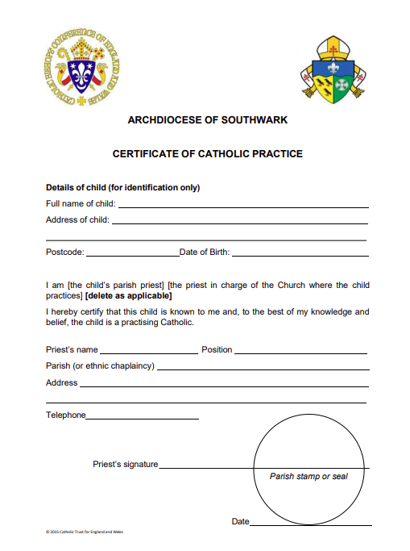

SAMPLE

