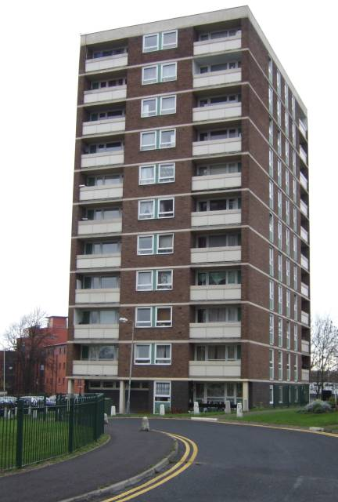
This Photo by Unknown Author is licensed under CC BY-SA

RESPECT FOR TENANTS, LEASEHOLDERS & FREEHOLDERS AND EFFECTIVE COMMUNICATION

INTRODUCTION
This report has been produced for the Housing Improvement Board of Croydon by its Tenant Members. It was originally planned to conduct a program of visits around council properties to gather information. That has not been possible at this stage due to COVID 19.
However, views and opinion have been gained by engaging with people via email, online meetings and forums (Zoom) and social media. To give an example six Tenant Involvement members were emailed to obtain feedback from estates and communities which included speaking with frontline staff such as caretakers and the South Norwood Tenants forum hosted by Steve Reed MP and local Councilor’s and a meeting sponsored by the Croydon Community Consortium.
HISTORICAL FEEDBACK
The ARK Independent Report and the Regulator established that the people who received a service from Croydon Council staff and Managers were not treated with respect or were not communicated with effectively. The attitude towards tenants was severely flawed and not acceptable.

In addition, this view has been raised at Tenant Involvement forums with Managers at Head of Service and on occasion Directors, but those views were ignored, and various actions raised and agreed were not implemented.

REACTION
Since May 2021 the Senior Management and Senior Councilors have accepted these issues and have listened intently at various forums to people’s voices. We have been told that “all staff will undergo training and the culture will change” a focus group has been set up with tenants to produce the relevant training package but that seems to be floundering.
So, the question is when will training of the council staff begin and attitudes change? We have been told that contractors will now be managed more closely.
It may have begun but tenants are still experiencing grave difficulties. In particular with axis for repairs.

TENANT COMMENTS/EVIDENCE
Enquiries and complaints not dealt with
I get an attitude of “it’s not my job”
I don’t know who my tenancy officer is to raise issues of concern
I am passed from pillar to post
I have never been given the name of the person dealing with an issue, so it doesn’t get resolved
I am asked to provide evidence then told it’s not enough (i.e., medical evidence/letter requested, provided by tenant at cost to them, then told its not acceptable)
Our caretaker gets frustrated with reporting upline as it falls on deaf ears
There is nothing we can do about that, “I am sorry”
Damp & Mold issues dismissed
Lack of Safeguarding
Delay in reports before repair is done
Wooderson Close Tenants ignored before 106 agreement made on relocation and are still being ignored as Council Officers will not meet to discuss relocation issues ( note Cabinet Member ignoring tenant issues as well)
Not enough transparency and support on Housing List matters and rudeness and dismissive bahaviour to discourage bidding
A lack of cohesion between departments and poor communication( Department within housing not speaking with each other.
Housing Needs management and process poor resulting in families being in temporary accommodation to long.
Reported lifts broken (in disrepair for years) and communal doors also broken reported to repairs but no action result that pregnant mums and elderly affected and food deliveries not possible to residents.
Council homes lying empty due to work being delayed, has been empty for 10 weeks, enquiries by neighbor ignored

NOTE: - General view is things are not getting better they are getting worse!

RESPECT
Is to show consideration for the feelings, individual’s needs, wishes and rights of all Council Residents which are Tenants, Leaseholders and Freeholders

*TO LISTEN
Council Staff and Council must listen to the Council Resident
*TO HEAR
The Council Staff must hear what is being said and not be dismissive or pass the buck
*TO UNDERSTAND
The Council Staff must understand the issues, what is of concern or worry to the council resident needs to be dealt with (i.e. a repair of say brickwork in the Residents view is needed due to it being dangerous! This should be understood and not dismissed or passed on)
*TO ENGAGE
Council Staff must engage with the person calling and put themselves in the shoes of the resident.

*TO HELP
Council Staff must accept that their primary role is to the resident and provide the help and support that is required with Health and wellbeing, Respect for people’s time, their age

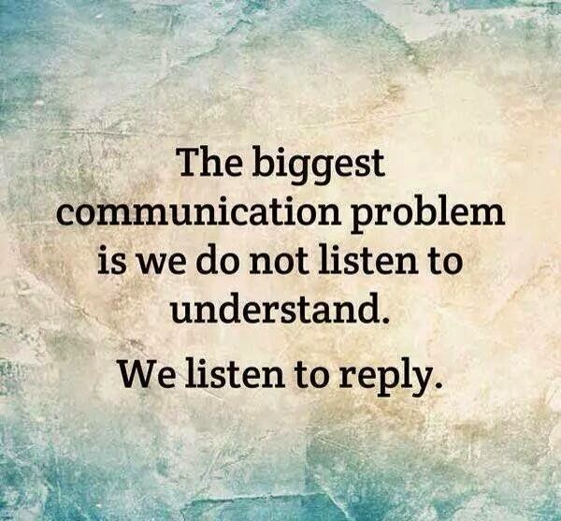
This Photo by Unknown Author is licensed under CC BY

EFFECTIVE COMMUNICATION
Question “do Council Residents feel they are communicated with effectively?”
Answer “No!”
What should Council Residents expect from staff when communicating

CLARITY

COURTEOUS

CONSIDERATE

CLEAR

BE CORRECT

CONCISE

BE CONSULTED BEFORE DECISIONS ARE MADE

SHARE INFORMATION AND PROCEDURES (e.g., Decant, Relocation, compensation, complaint
It should be accepted that these standards should apply to all aspects of communication with residents (face to face, phone, email, letter, online – zoom , teams and My Account

RECOMMENDATIONS
- TENANT/RESIDENT REPRENTATIVES AND DIRCTOR TO MEET AND AGREE STANDARDS TO BE DEPLOYED BY ALL EMPLOYEES WHEN DEALING WITH TENANTS AND RESIDENTS, THAT A TIMELINE BE SET FOR AGREEMENT AND IMPLEMENTATION.

EXAMPLE STANDARDS
- All telephone calls to be answered within 5 rings
- All emails to be answered within 48 hours
- All letters to be answered within 5 working days
- The officer to be named and contact details given to the Tenant/Resident dealing with the issue
- Interim updates to be given to the tenant/resident
- Matters raised to be resolved within 14 days or sooner

- THAT THE “WAY FORWARD REPORT” SUMITTED TO BOTH SENIOR MANAGERS AND CABINET MEMBER BY THE TENANT & LEASEHOLDER PANEL BE PRIORITESED AND A TIMELINE BE AGREED FOR DSICUSSSION OF THE CONTENT AT DIRECTOR LEVEL.

- THAT THERE IS A COMPLETE AND UGENT REVIEW OF THE COMPLAINTS PROCEDUE AS THE CURRENT GENERIC PROCEDIRE DOES NOT ADDRESS RESIDENT COMPLAITNS REGARDING SERVICES.

- THAT THEME 1 OF THE ALL PARTY REPORT ON GOVERNANCE 2020 REFRECENCING RESIDENTS INVOVEMENT IN DECISION MAKING BE IMPLEMENTED URGENTLY

