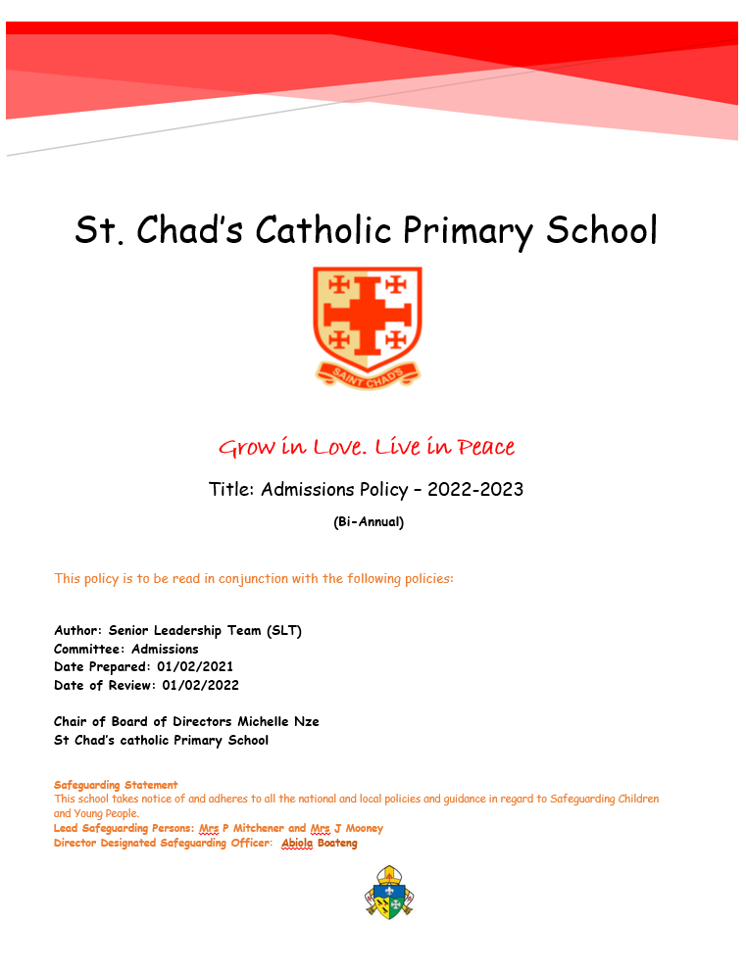

St Chad’s Catholic School
Admissions Policy 2022-2023
St Chad's Catholic Primary School is an academy in the Diocese of Southwark. It is in the trusteeship of
the Diocese. The school is conducted by its Board of Directors as part of the Catholic Church in
accordance with its Articles of Association, and seeks at all times to be a witness to Jesus Christ. The
school exists primarily to serve the Catholic community and Catholic children always have priority of
admission. However the Board of Directors also welcomes applications from those of other
denominations and faiths and from those who have no faith who support the religious ethos of the
school.
A maximum of 60 children who are between the ages of 4 and 5 years old at the time of entry will be admitted each year without reference to ability. Foundation and KS1 classes are legally required to admit no more than 30 children per class. At St Chad’s the directors have decided to limit classes in KS2 to 30 children. The Board of Directors may also admit older children subject to the availability of places in their age group and provided the criteria herein are met.
Supplementary Information Form will be available from school and the school’s website in the academic year prior to the year of entry.
If your application is unsuccessful you may ask for your child’s name to be added to a waiting list. This
list will be maintained until the end of the autumn term of the year of entry. The admissions criteria will still
apply.
Late applications will be received by the school but these applications will not be processed until the initial round of offers has been made.
The Admissions Policy is reviewed annually by the Directors of St Chad’s School in the light of guidance from the diocese and is subject to consultation with the Local Authority.

Nursery Admission Arrangements

The intention of the school is to admit up to the equivalent of 26 full-time places to the Nursery classes formed for intake in September 2022. Places are offered without reference to ability or aptitude. Children will be admitted at the beginning of the school year in which they become four. The school intend to offer both full and part-time places taking into account parental preferences. If you would like to apply for a place for your child in our nursery class, please contact the school office where you will receive information on application forms and the timescales for applying. If we receive more applications than there are places available at that time in our nursery class, we use the criteria stated in the school’s admissions policy to prioritise applications.

Admission to the Nursery does not guarantee admission to Reception.
Reception class
Admission Procedures
All parents, wishing to apply for a Reception place, must complete a Common Application Form (available from the child’s home Local authority).
Supplementary Information Form (SIF)
To apply for a place at St Chad’s you should complete two separate forms:
1. The Common application Form from the child’s home Local authority, naming St Chad’s Catholic
school as one of the preferences (this form is to be returned to the Local Authority or submitted
through the online e-admissions system).
2. The SIF, available from the school or via the school’s website, needs to be returned to the Admission’s Officer at St Chad’s School no later than the date published on the form. This should be completed and returned to the school even if the CAF is completed online.
The school will, in addition, require a reference from your parish priest and a copy of the child’s baptism certificate.
Completion of a SIF is not mandatory; however, if one is not received the directors will not be able to
apply their admission criteria and the application will be considered under the ‘any other children’
category
You are advised to make copies of the completed forms returning the original SIF to the school office and retaining a copy.
Admissions criteria
After the admission of children with an Education, Health and Care Plan (EHCP) that names the school, the following criteria will be used to prioritise applications when oversubscribed:
1. Looked-after Catholic children or looked after children in the care of Catholic families and
previously looked after Catholic children who have been adopted or who have become the
subject of a residence or guardianship order.
2. Baptised Catholic children of practising Catholic parent(s) attending Mass weekly who have
siblings in St Chad’s School when the applicant is due to enter.
3. Baptised Catholic children of practising Catholic parent(s) attending Mass weekly who are:
3a Resident in St Chad’s parish͖
3b Not resident in St Chad’s parish.
4. Baptised Catholic children resident in St Chad’s parish whose Catholic parent(s) practice is
intermittent (three times a month or less). (Sibling priority)
5. Baptised Catholic children not resident in St Chad’s Parish whose parent(s) practice is
intermittent (three times a month or less). (Sibling priority)
6. Children whose families are enrolled in the catechumenate. Evidence of enrolment in the
catechumenate will be required. (Sibling priority)
7. Other looked after children or looked after children and other previously looked after children
who have been adopted or who have become the subject of a residence or guardianship order.
8. Children who are baptised members of Eastern Orthodox Churches. (Evidence of baptism
required). List available on request. (Sibling priority)
9. Children of families who are members of other Christian denominations that are part of
Churches Together in England. Evidence of baptism (or dedication) provided by a priest or
minister of a designated place of worship will be required. (Sibling priority)

10. Children of other faiths. Evidence of membership of the faith should be provided by a priest,
minister or religious leader or a designated place of worship will be required.(Sibling priority)
11. Any other children (sibling priority)

Tiebreaker

If it should become necessary to subdivide a group because sufficient places are not available to
take all the applicants in that particular group, then the directors will consider other factors such as: a) Social and Medical Needs that make the school particularly suitable for the child in question.
Strong and relevant evidence must be provided by an appropriate professional authority
(e.g. qualified medical practitioner, education welfare officer, social worker).
b) The distance will be measured in a straight line from the child’s home address to the
designated entrance of the school using a computerised measuring system (GIS) and
geographical reference points as provided by the National Land and Property Gazetteer (NLPG). Those living closer to the school will receive higher priority.
If a child lives in a shared property such as flats, the geographical references will determine
the start point within the property boundaries to be used for distance calculation purposes.
c) Where the last remaining place is to be allocated and two or more children are deemed to
live the same distance from the school the place will be decided by the drawing of lots.
Waiting lists

If the school is oversubscribed, parents of children who have not been offered a place at the school
may ask for their child’s name to be placed on a waiting list. In such cases, the school will maintain
a waiting list for one term in the academic year of admission. In-year waiting lists are also
maintained for a term. After this, parents may write to the school to ask for their child’s name to be
kept on our waiting list.

The waiting list will be operated using the same admissions criteria listed above. The school will not therefore maintain a ranked waiting list. Placing a child’s name on the waiting list does not
guarantee that a place will become available. This does not prevent parents from exercising their right to appeal against the decision not to offer a place.
In-year applications

Applications for a place at the school in-year must administered by the LA where the school is situated and not where the applicant is resident. This form must be returned to the LA. The school’s
Supplementary Information Form should also be completed to enable the directors to rank the
application in the event of there being more than one application for a place. The directors will use
the same criteria to rank the application as that listed above. In the event of the directors deciding
that a place cannot be offered parents will be offered the opportunity of placing their child’s name
on the waiting list. This does not prevent parents from exercising their right to appeal against the
decision not to offer a place.

Appeals

The deadline to lodge an appeal is 4th June 2022. Parents whose applications for places are unsuccessful may appeal to an Independent Appeal Panel set up in accordance with section 85(3) of the School Standards and Framework Act 1998. Appeals must be made in writing and must set out the reasons on which the appeal is made. Appeals should be made to the Admissions Appeal Clerk at the school address. Parents/Carers have the right to make oral representations to the Appeal Panel. Infant classes are restricted by the legislation to 30 children.
Parents should be aware that an appeal against refusal of a place in an infant class may only succeed if it can be demonstrated that:-
a) The admission of additional children would not breach the infant class size limit; or
b) The admission arrangements did not comply with admissions law or had not been correctly and impartially applied and the child would have been offered a place if the arrangements had complied or had been correctly and impartially applied; or
c) The panel decides that the decision to refuse admission was not one which a reasonable admission authority would have made in the circumstances of the case.
Parents/Carers have the right to make oral representations to the appeal panel.
Children of multiple births:
If it is not possible to offer a place to all of the children, the names of those children who were unsuccessful will be accorded sibling priority on the waiting list.
Glossary of terms:

Baptised In a Catholic Church with certificate which is available.
The Parish Parish boundaries are laid down by the Archdiocese of Southwark. A map is
available in the school office.
Resident The normal registered place of residence of the parents and children, not that of the childminder or relative. Proof of residency may be requested.
Practising Catholic Means Catholic children from practising Catholic families who habitually
worship at Mass weekly and where the application is supported by a
Catholic priest. The directors will expect this practice to be verified by a reference from a priest.

Intermittent

Parent(s)
Sibling

Note 1:
Looked-after children
Means ’does not always fulfil the obligation of attendance at Catholic Mass each Sunday and Holy Day or the eve of such days.
Means parent(s)/guardian(s).
A sibling is defined as a brother or sister, half brother or sister, step brother or sister or adopted brother or sister, foster brother or sister whose main residence is at the same address.

Are defined as children in public care at the date on which the application is made.

Previously looked-after children
Are children who were looked after, but ceased to be so because they were adopted or became subject to a residence order or special guardianship order, immediately after being looked-after.

If an application is made under the ‘looked after’ criterion, it must be supported by a letter from the relevant local authority children’s service department.

Admission of children below compulsory school age

The directors will provide for the admission of all children in the September following their fourth
birthday. Parents can request that the date their child is admitted to the school is deferred until
later in the school year or until the child reaches compulsory school age in that school year; parents
may also request that their child attends part-time until the child reaches compulsory school age.

Admission of children outside their normal age group
Parents who are seeking a place for their child outside of their normal age group, eg, the child has experienced problems such as ill health or the parents of a summer born child choosing not to send that child to school until the September following their fifth birthday, may request that they are admitted out of their normal age group - to Reception rather than Year 1.

Directors will make decisions on the circumstances of each case and in the best interests of the child concerned. This will include taking account of the parent’s views͖ information about the child’s academic, social and emotional development; where relevant, their medical history and the views of a medical professional; whether they have previously been educated out of their normal age group, and whether they may naturally have fallen into a lower age group if it were not for being born prematurely. They will also take into account the views of the school’s head teacher. When informing a parent of the decision which year group the child should be admitted to, the directors will set out clearly the reasons for their decision.
Where the directors agree to a parent’s request for their child to be admitted out of their normal age group and, as a consequence of that decision, the child will be admitted to the age group to which pupils are normally admitted to the school the local authority will process the application as part of the main admissions round, (unless the parental request is made too late for this to be possible) and on the basis of the determined admission arrangements, including the application of oversubscription criteria where applicable. Parents have a statutory right to appeal against the refusal of a place at a school for which they have applied. This right does not apply if they are
offered a place at the school but it is not in their preferred age group.

Pupils with a Statement of Special Educational Needs or Education, Health and Care (EHC) Plan
The admissions of pupils with a Statement of Special Educational Needs or with an EHC Plan are dealt with by a completely separate procedure. The procedure is integral to the making and
maintaining of statements and EHC plans by the pupil’s home local authority. Details of this
separate procedure are set out in the SEND code of practice. Pupils with a statement or EHC plan naming the school will be admitted without reference to the above criteria.

Criteria for Over Subscription to St Chad’s School/Nursery
After the admission of children with a statement of special educational need that names the school, the following criteria will be used to prioritise applications when oversubscribed:
1. Looked-after Catholic children or looked after children in the care of Catholic families and
previously looked after Catholic children who have been adopted or who have become the
subject of a residence or guardianship order.
2. Baptised Catholic children of practising Catholic parent(s) attending Mass weekly who have
siblings in St Chad’s School when the applicant is due to enter.
3. Baptised Catholic children of practising Catholic parent(s) attending Mass weekly who are:
3a Resident in St Chad’s parish͖
3b Not resident in St Chad’s parish.
4. Baptised Catholic children resident in St Chad’s parish whose Catholic parent(s) practice is
intermittent (three times a month or less). (Sibling priority)
5. Baptised Catholic children not resident in St Chad’s Parish whose parent(s) practice is
intermittent (three times a month or less). (Sibling priority)
6. Children whose families are enrolled in the catechumenate. Evidence of enrolment in the
catechumenate will be required. (Sibling priority)
7. Other looked after children or looked after children and other previously looked after children
who have been adopted or who have become the subject of a residence or guardianship order.
8. Children who are baptised members of Eastern Orthodox Churches. (Evidence of baptism
required). List available on request. (Sibling priority)
9. Children of families who are members of other Christian denominations that are part of
Churches Together in England. Evidence of baptism (or dedication) provided by a priest or
minister of a designated place of worship will be required. (Sibling priority)
10. Children of other faiths. Evidence of membership of the faith should be provided by a priest,
minister or religious leader or a designated place of worship will be required.(Sibling priority)
11. Any other children (sibling priority)

