Highways Development
Floor 6 – Zone C
8 Mint Walk
Surrey
CR0 1EA

CONTACT: highwaysdevelopment@croydon.gov.uk

Vehicle Crossover Application Pack

Thank you for your recent enquiry about a vehicle crossover (Dropped Kerb). I enclose the application form and crossover guidance that you need to read and complete in order to apply for a vehicle crossover in Croydon.
Agreement for Installation:
Please read the agreement for installation and Crossover guidance which sets out the conditions which you must meet with regard to parking a vehicle on your property. If you comply with all the conditions then sign and date the installation form. Please attach a photocopy of your vehicle registration document and a non-refundable cheque for £150 made payable to ‘London Borough of Croydon ‘. This charge covers the processing of your application and the provision of an estimate of the works required.
If you do not comply with all the conditions on the agreement please do not make payment or return a form as your application will not be granted. If the new crossover is located within a Classified Road or Conservation Area, you will require planning permission as noted in the Crossover Guidance. On receipt of your cheque the highways team will organise a site visit to your property and prepare an estimate for the cost of constructing the vehicle crossover. When Payment is received we will aim to commence the works within eight week.
Please return the completed form to the address at the top of this letter.

Yours sincerely,

Highways Development Control

Acceptable Parking Arrangements
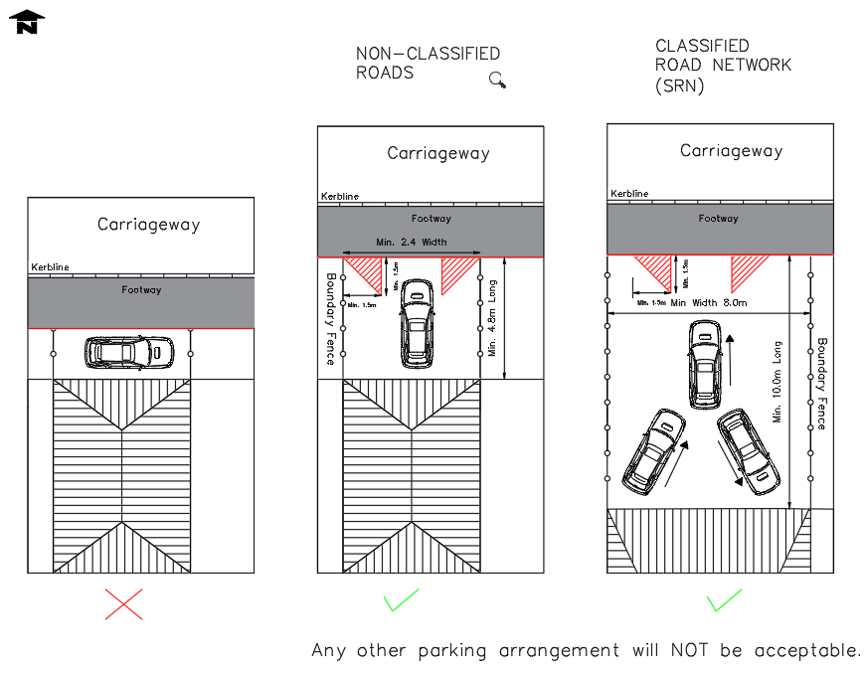

APPLICATION FOR INSTALLATION OF A VEHICLE CROSSOVER

APPLICATION ADDRESS (complete the fields below):

*1st Line of Address: ____________________________________
*2nd Line of Address: ____________________________________
*Town: ____________________________________
*Postcode: ____________________________________

- Parking in front of an entrance or on any part of the pavement including the dropped kerb is an offence under Section 137 of the Highways Act 1980 as is allowing any vehicle parked within the property to overhang any part of the highway/pavement and therefore not permitted

- The Parking area within the property must be constructed to the specification stated within the Crossover Guidance and Croydon Planning Policies. The construction details are subject to verification by the council and the hardstand material must not spread onto the Public highway. Parallel parking will not be considered under any circumstances. The full length of the vehicle must be contained within the property boundary as well as clearance of a minimum of one metre for access and egress from the premises. The vehicle must be able to cross the footway and enter and exit the property in a single movement. No part of the vehicle shall overhang onto the footway.

- The crossover provided by the council will not extend beyond the frontage of the property and will not exceed 4.0 metres (see crossover guidance). Please note: to minimise the loss of kerbside parking only one crossover will be permitted per property. The hardstanding area (material of choice) must be prior approved by the Council Officer before the construction of the vehicle crossover.

- It is the resident’s responsibility to ensure that surface water from their drive does not discharge onto the pavement. For hardstanding put in place after 1 October 2008 you will be expected to demonstrate it has been constructed such that surface water from the drive does not:-

  - Discharge onto the pavement/highway
  - Add to flood risk and pollution

You can provide paved areas that controls and reduces rainfall runoff into drains by using permeable surfaces or soakaways and rain gardens (a small planted depression designed to manage rain water). For more information about how to construct your drive so that it does not add to flood risk and pollution please refer to environment agency leaflet “Guidance on the permeable surfacing of the front gardens” by visiting https://www.gov.uk/government/publications/permeable-surfacing-of-front-gardens-guidance. The choice of material must not spread onto the highway.

- It is the Council’s policy to retain all the trees on the highway to preserve the visual amenity of the area and a minimum of 1.5 metres between a tree and crossing is required. Trees will not be removed to allow a crossover to be constructed. Please refer to Crossover Guidance for further information.

- I have enclosed a copy of the vehicle registration document for the largest vehicle that will normally be parked on the property. Please tick box to confirm .

Please confirm either 1 or 2 below:
- I have obtained planning permission for a vehicle access (copy attached)

- I do not need planning permission because (all of the following criteria must be ticked):

- I live in a house which is occupied by my household only and is not subdivided into flats or bedsits.
- I do not live on a main road which is listed as a ‘classified road’ (please see the enclosed list of classified roads)
And (at least one of the following criteria must be ticked)

- I have an existing hard standing which has been in place since before 1 October 2008
- The driveway will be formed of porous materials, on a porous base*
- The driveway will be constructed in a way which allows surface water to run off into a porous or permeable area within the grounds of my property
- The hard standing area is to the side of my property, and would not be forward of the front of the house
I confirm that the above information is correct to the best of my knowledge. I acknowledge that is if I apply for a drop kerb and the statement above is found to be incorrect, the highways team will not be able to proceed with the installation and the dropped kerb application fees will not be refunded. Furthermore, planning permission may also be required.
I confirm that I have read and understood the above criteria and I will abide by this agreement.
I also acknowledge and agree that, should there be an evidence of regular abuse of the above conditions the council reserves the right to remove the dropped kerb at my expense. Please tick box to confirm.

*Signature:……………………………………. *Date………………………………………….
*Name (print): …………………………………………………………………………………...

Remember - Please pass this agreement to the purchaser if you sell your property

*Contact Name: …………………………….. *Telephone…………………………………..
*Home address: ……………………………………………………………….........................

*Porous Material include:
- Special designed porous bricks
- Special designed porous asphalt
- Well-spaced bricks, infilled with sand or a similar material that water can pass through.
Hard standing formed of or laid on concrete are not acceptable.

For dropped Kerb Queries, please contact the highways team at:
Highwaysdevelopment@croydon.gov.uk

For planning applications:
https://www.croydon.gov.uk/transportandstreets/rhps/pavements/crossovers/vehaccess1

LONDON BOROUGH OF CROYDON
CLASSIFIED ROADS
REQUIRING PLANNING PERMISSION
ROAD/STREET NAME CLASS

Aberdeen Road Class B
Addington Road, Sanderstead/Selsdon Class A
Addington Village Road Borough Classified
Addiscombe Road Class A
Auckland Road Borough Classified
Banstead Road Class A/Trunk Road
Barclay Road Class A/Borough Classified
Bensham Lane Borough Classified
Bensham Manor Road Borough Classified
Beulah Hill Class A
Birchanger Road Borough Classified
Blackhorse Lane Borough Classified
Bramley Hill Borough Classified
Brighton Road Class A/Trunk Road
Brigstock Road Class B
Cameron Road Borough Classified
Campbell Road Borough Classified
Canterbury Road Borough Classified
Carlton Road Borough Classified
Central Hill Class A
Chepstow Road Class A
Cherry Orchard Road Class A
Chipstead Valley Road Class B
Church Road, Upper Norwood Class A
Coombe Lane Class A
Coombe Road Class A
Coulsdon Road Class B
Crescent The Borough Classified
Croham Road Borough Classified
Croham Valley Road Borough Classified
Crown Dale Class A
Crown Lane Class A
Crowther Road Borough Classified
Croydon Road Class A
Davidson Road Borough Classified
Denning Avenue Class B
Dingwall Road Borough Classified
Downs Court Road Class A
Duppas Hill Road Class A
Edgehill Road Borough Classified
Elborough Road Borough Classified
Epsom Road Class A/Borough Classified
Fairfield Road Class A
Farley Road Borough Classified
Featherbed Lane Borough Classified
Flyover The Croydon Class A
Foxley Lane Class A/Trunk Road
George Street Class A/Borough Classified
Glade The, Shirley Borough Classified
Godstone Road Class A
Grange Road, Upper Norwood Class A
Gravel Hill Class A
Green Lane, Norbury Class B
Haling Park Road Borough Classified
Hartland Way Borough Classified
Hayes Lane Borough Classified
High Street, Croydon Class A
High Street, South Norwood Class A
High Street, Thornton Heath Class B
High Street, Purley Class A
Highfield Road Borough Classified
Hogarth Crescent Class A
Holland Road Borough Classified
Junction Road Borough Classified
Kent Gate Way Class A
Limpsfield Road Class B
Lion Green Road Class A
Little Woodcote Lane Class A
Lodge Lane Borough Classified
London Road Class A/Trunk Road
Long Lane Class A
Lower Addiscombe Road Class A
Lower Coombe Street Class A
Manor Road Class A
Marlpit Lane Class B
Mayfield Road, Sanderstead Borough Classified
Melfort Road Borough Classified
Mitcham Road Class A
Mitchley Avenue Class A
Monks Orchard Road Borough Classified
Morland Road Class B
Newgate Class A
Norbury Crescent Borough Classified
North End Class A
Northborough Road Borough Classified
Northcote Road Class A
Northwood Road Borough Classified
Oakfield Road Borough Classified
Old Farleigh Road Borough Classified
Old Town Class A
Orchard Avenue Borough Classified
Pampisford Road Borough Classified
Parchmore Road Class B
Park Hill Road Class A
Park Lane Class A
Park Road, Kenley Borough Classified
Park Road, SE25 Borough Classified
Pawsons Road Borough Classified
Penge Road Class A
Plough Lane Class B
Portland Road Class A
Portnalls Road Borough Classified
Pump Pail North Class A
Pump Pail South Class A
Purley Downs Road Borough Classified
Purley Road, Purley Class A/Trunk Road
Purley Way Trunk Road
Rectory Park Class A
Reeves Corner Borough Classified
Roman Way Class A
Russell Hill Road Trunk Road
Sanderstead Hill Class B
Sanderstead Road Class B
Selhurst Road Class A
Selsdon Park Road Class A
Selsdon Road Class B
Shirley Church Road Borough Classified
Shirley Road Class A
Smitham Bottom Lane Class A
Smitham Downs Road Class B
South End Class A
South Norwood Hill Class A
South Park Hill Road Class B
Southbridge Road Class A
Spa Hill Borough Classified
Spout Hill Borough Classified
Spring Lane Class A
St Helen’s Road Borough Classified
St James’ Road, Croydon Class A
St Peter’s Road Class B
St Saviour’s Road Borough Classified
Stafford Road Class A
Stanford Road Borough Classified
Station Road, West Croydon Borough Classified
Stoats Nest Road Class B
Sumner Road Class A
Sussex Road Borough Classified
Sydenham Road Borough Classified
Tamworth Road Borough Classified
Tennison Road Borough Classified
Thornton Road Trunk Road
Underpass The Croydon Class A
Upper Selsdon Road Class B
Upper Shirley Road
(Wickham Road to Shirley Church Road) Class B
Waddon New Road Borough Classified
Waddon Road Borough Classified
Warham Road Class B
Wellesley Road Class A
Westow Hill Class A
Westow Street Borough Classified
Whitehorse Lane Class B
Whitehorse Road Class A
Wickham Road Class A
Windmill Road Class A
Woodcote Grove Road Class A
Woodcote Road Class A
Woodside Avenue Borough Classified
Woodside Green Class B/Borough Classified

