Children Missing from Education
& Pupils Added/Removed from Roll

Information & guidance for all schools, including independent schools, free schools & academies

Version 5 – Updated September 2019

Children Missing from Education and Pupils Added/Removed from Roll
Guidance for Education Providers
Version 5 – Updated September 2019
CHILDREN MISSING FROM EDUCATION (CME)
- Introduction
Croydon Council is concerned about any child missing education, as it is not just attainment at risk, but also potentially safety and welfare. Children who are not receiving a suitable education are more likely to be vulnerable and at risk of negative outcomes which may have implications on later life chances. They are also at greater risk of becoming NEET (Not in Education, Employment or Training).
The key purpose of the Children Missing Education (CME) Policy is to ensure that children missing, or at risk of missing, education are identified, monitored and re-engaged in appropriate full-time education with lasting success, and that children who move out of Croydon they are monitored until they are engaged in education elsewhere, so that no child ‘slips through the net’.
a) Legal context
In summary the procedures in this policy support:
- The Education and Inspections Act 2006 which places a duty on local authorities to make arrangements to enable them to identify children and young people of compulsory school age missing education in their area.

- These procedures are in line with the Local Authority’s statutory duty under Section 436A of the Education Act 1996, as amended by Section 4 of the Education and Inspections Act 2006, which requires all local education authorities to make arrangements to establish (so far as it is possible to do so) the identities of children in their area who are not registered at a school, for example, at home, privately or in alternative provision, and are not receiving a suitable education;

- Section 175 of the Education Act 2002, which places a duty on local authorities to exercise their functions with a view to safeguarding and promoting the welfare of children;
In January 2009 revised Statutory Guidance was issued for Local Authorities in England to identify Children Not Receiving a Suitable Education (this guidance has since been revised again and reissued in a much-slimmed down version). Further statutory guidance was published in July 2015 and revised September 2016 in the Keeping Children Safe in Education document.
The policy should be read in conjunction with:
- The Education (Pupil Registration) Regulations 2006 amended 2016

- Children Missing Education – Statutory Guidance, DfE 2016

- School Attendance – Statutory Guidance, DfE 2019

- Keeping Children Safe in Education – Statutory Guidance, DfE 2019

- Croydon Safeguarding Children Board Interagency Policies and Procedures
b) Purpose of the document
This document is intended to inform Local Authority (LA) staff, head teachers, governing bodies of schools and other involved agencies about the policy and procedures to be followed in order to prevent children becoming Children Missing Education (CME). Unless otherwise specified, ‘school’ means all schools whether maintained, non-maintained or independent schools, including academies and free schools, alternative providers and pupil referral units.
The best way for Croydon Council and schools to support the welfare of all children is to ensure that they are all on a school roll and that children do not ‘slip’ off school rolls and become ‘missing’ or that they are registered with the LA as home educated. All schools are strongly encouraged by Croydon Council to adopt this policy as good practice.
The purpose of the Children Missing Education (CME) policy is to enable the Local Authority to fulfil its statutory duty to provide education for all children of compulsory school age. It also outlines the processes in place to identify and monitor children and young people missing education, identify those at risk of becoming missing from education and the monitoring systems to ensure that action is taken to re-engage them with ‘suitable education’. ‘Suitable education’ is defined as efficient full-time education suitable to their age, ability and aptitude and to any additional educational needs.
The policy applies to children of compulsory school age who are not on school roll, who are not receiving a suitable education otherwise than being at school and have been out of any educational provision for a substantial period of time. In relation to children who are registered at a school and not attending regularly this would be subject to interventions through existing education welfare procedures.
The duty to identify children not receiving an education does not apply to children whose parents have chosen to electively home educate them. Parents have a duty to ensure that their children receive an efficient and suitable full-time education. This may be through regular attendance at school or otherwise (Section 7, Education Act 1996), and they may arrange this outside the state or independent school system.
Procedures within this policy will also ensure that all children’s services in Croydon:
- Meet statutory duties relating to the provision of education and safeguarding the welfare of children missing education
- Ensure that robust multi-agency systems are in place to identify and oversee children missing education or at risk of missing education
- Ensure that monitoring and reporting systems are in place in order to identify an allocated worker for all children missing education.

c) Definition for Children Missing Education (CME)
A Child Missing from Education is defined by the DfE as “a child of compulsory school age who is not on a school roll, nor being educated otherwise (e.g. privately or in alternative provision) and who has been out of any educational provision for a substantial period of time (usually four weeks or more).” In Croydon, referrals for CME are accepted after 10 working days of reasonable checks being carried out by the educational provider and their Designated Safeguarding Lead.
Section 436A of the Education Act 1996 (as amended by the Education and Inspections Act 2006) requires all local authorities to make arrangements to enable them to establish (so far as it is possible to do so) the identities of children residing in their area who are not receiving a “suitable education”. We stand a better chance of ensuring a child’s safety if we know how and where they are receiving their education.
By “suitable education” we mean efficient full-time education suitable to the child’s age. Children Missing from Education should not be confused with:
- Children who are on roll at a school but are not in regular attendance. In this case, referrals should be made to the Education Welfare Service, or the school’s Attendance and Welfare Officer;

- Children who are receiving Home Education (known as Elective Home Education);

- Children whose parents have applied for a school place, and the application is being dealt with via the Admissions procedures.
It is important that all agencies work closely together to ensure that the dangers of children becoming missing from education are reduced, as these children are at much greater risk of significant harm and are particularly vulnerable. The Children Act 2004 places a duty on all agencies to work together to promote the welfare of children and to share information appropriately.
All information is processed in accordance with the General Data Protection Regulation 2016 and Data Protection Act 2018.
The processing of personal information is necessary for:
- Compliance with a legal obligation (Article 6.1(c)) and/or
- The performance of a task carried out in the public interest (Article 8.1(e)).
The processing of special category information is necessary for:
- The purpose of carrying out obligations in the field of social protection law (Article 9.2(b)); or
- The establishment, exercise or defence of legal claims (Article 9.2(f); or
- Reasons of substantial public interest (Article 9.2(g). In particular it is necessary for the purposes of exercising a function conferred on the Council by an enactment (Statutory and government purposes – Data Protection Act 2018 - Schedule 1, Part 2, paragraph 6(2)(a)).
As noted above, Croydon Council has a duty to ensure that children within its boundaries are being appropriately educated, and it is necessary for this function that we obtain this information.
In Croydon, the main reasons behind Children Missing from Education are those who fail to start at an appropriate education provision either at the start of the new academic year or following a mid-year transfer, becoming lost from school rolls, or failure to register at a new school when moving in or out of the Borough.
Unfortunately there are also many other explanations behind CME, meaning that there are a lot of possible variants. As well as the main reasons already stated, please see below for a list of potential alternative triggers of CME and circumstances which may make a child more likely to be affected by these factors:
- Moving in and out of boroughs and beginning the school application process;
- Failure of schools to notify the Local Authority of a child being off-rolled, or being excluded;
- Withdrawal of a child from school by the parent/ carer;
- Failure to transition between schools;
- Disengagement;
- Frequent house moves, periods of homelessness or time spent in refuge/ temporary accommodation;
- Youth Offending Service involvement;
- Generational disengagement;
- Children of Gypsy, Roma and Travelling families;
- Children of immigrant families;
- Asylum seeks and unaccompanied minors (Looked After Children);
- Young carers;
- Children with Special Educational Needs;
- Children who are privately fostered or are known to Children’s Social Care (e.g. Child Protection Plan, Child In Need)
- Trafficked children;
- Children who have experienced domestic violence and other adverse family circumstances.
By identifying and working with these families, Croydon aim to reduce the number of children and young people who are missing from education. Statistics shows that children who suffer from a history of poor attendance, or have periods of missed education, are more likely to face future issues in relation to:
- Homelessness
- NEET (Not in Employment, Education or Training)
- Anti-social/ Criminal behaviour
- Social disengagement
- Mental health issues
- Substance abuse
- Neglect and emotional abuse
- Sexual exploitation/ involvement in the sex trade
- Teenage parenthood
- Physical health issues
- Forced marriage
- Poverty
- A multi-agency approach

Children who remain disengaged from education provision are potentially exposed to higher degrees of risk that could include engagement in anti-social or criminal behaviour, social disengagement and/or sexual exploitation. Children and young people from these groups often have complex needs due to difficult family dynamics or social or lifestyle factors, all of which may contribute to the withdrawal process and failure to make successful transition. The vulnerability of many children missing education requires that practitioners across all agencies and services use multi-agency approaches to identify and re-engage these children and their parents to return to appropriate education quickly and to develop action plans and make relevant referrals to ensure successful reintegration.
- Missing Monday Panel
The Missing Monday panel was introduced in September 2015. “Missing Monday” is a weekly multi-agency panel whose purpose is to help reduce the numbers of children and young people in Croydon who are absent from education, or who go missing from a school roll. The panel consists of LA services from Learning Access, School Admissions, YOS, Early Help, CSC and Safer London. The panel adopts a multi-agency approach to form a holistic picture of the child and to identify a lead agency and clear actions to support a return to accessing education.
Services are able to refer individual pupils to the panel to access a multi-agency approach which captures the relevant information around that child speedily, reducing the risk of children falling through the gaps. Where the panel has sufficient concerns re a child referrals will be escalated.
b) Children Missing Education referral processes
Croydon Council employs a dedicated Children Missing Education Officer whose role is to receive notifications of children possibly missing education, and to manage local procedures in line with statutory guidance.
c) The Local Authority / Children Missing Education Officer will:
- Produce a written policy and procedure which will be reviewed annually
- Ensure that there are embedded arrangements to identify and provide services for children missing education
- Identify and provide clear notification routes and processes for key stakeholders
- Investigate Children Missing Education referrals made by schools, other agencies and other LA’s
- Support the Fair Access Panel and out of school children and families with action planning for reintegration into education where possible
- Maintain a database of CME
- Use the Lost Pupil Database area of the S2S site for recording children missing education
- Ensure that up to date information regarding school places and access to alternative provision is readily available
- Ensure appropriate monitoring systems are in place
- Deliver training to schools and agencies to support the CME function, if requested
- Support schools to make an effective contribution to the referral processes
- Support and encourage schools to transfer files via S2S
- Monitor the effectiveness of processes
- Information share with other services including the point of contact for CSE
- Provide reports to senior managers, elected members, the LSCB and the DfE against agreed criteria
- Ensure representation at regional and local meetings

CME Risk Assessment and checks
Once a CME/Leaver Notification has been received, the CME Officer will conduct an initial risk assessment based on the presenting information and an initial check to see if the child is currently known to Children’s Social Care. The risk assessment process will help prioritise the CME caseload to ensure the most urgent cases are dealt with promptly and appropriately.
Once a case has been prioritised, checks will be carried out to gather information in relation to the child and their family which may help to locate the child. These checks may include:
- Information to be gathered from the previous school, e.g. attendance, behaviour, any risk factors;
- Does the child have any siblings of school age;
- Is any information available in relation to the siblings’ current educational status;
- Are the family known to the Youth Offending Service;
- Have any members of the family come to attention on the PNC (Police National Database)
- Are any of the family members known to any internal agencies, e.g. Family Resilience Service, CYPRS, SEN
- Relevant information from the LA’s benefits database
Notifications will be returned to the referrer if:
- the form has not been fully completed;
- the presenting issue is poor attendance and the child is not missing from education, i.e there is not information to suggest that the child and/or family have moved away from Croydon;
- all necessary checks listed on the form haven’t been completed prior to the notification being made;
Appendix One includes a detailed flowchart for internal CME processes.

Risk Assessment
All cases should be continuously risk assessed to ensure actions are conducted based on the current level of risk. The timeline below displays our current response times based on the level of need. Response times may differ dependant on current CME caseloads.
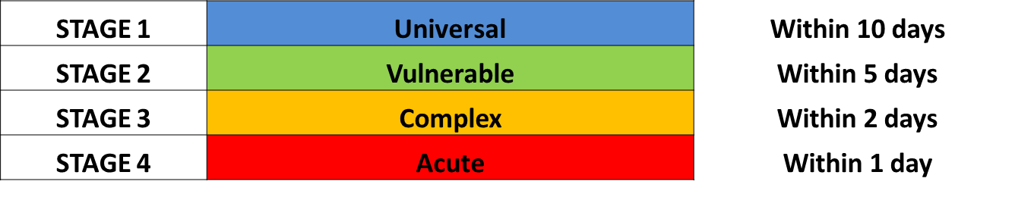

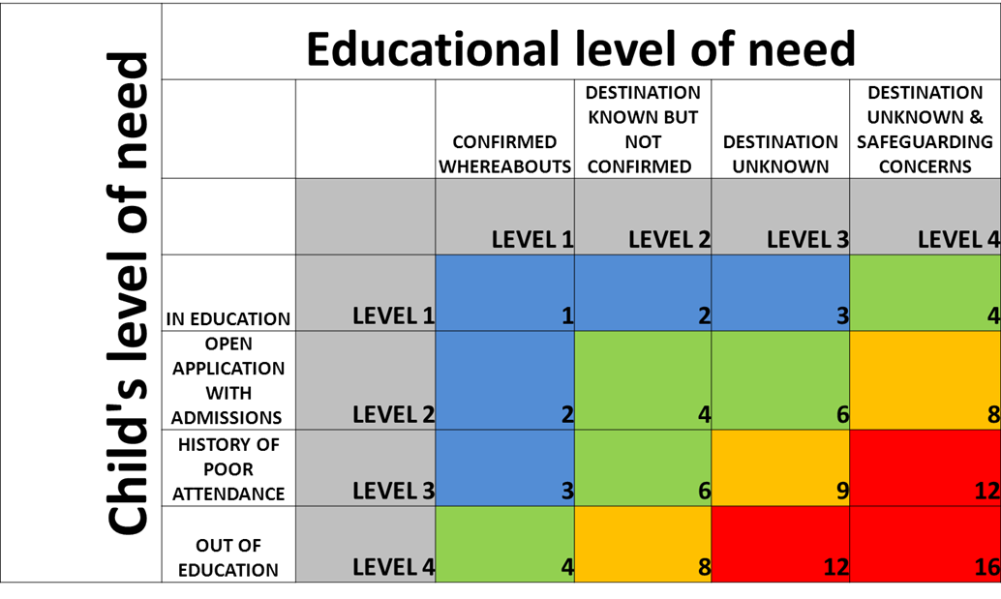
Children Moving Abroad will be treated as Destination Unknown (Level 3) or higher in all circumstances
Failure to engage
Should a parent refuse or fail to engage with the CME or EHE team, and not actively seek a school place, it may be necessary for the relevant Officer to make a referral to the EWS in order for a School Attendance Order, and subsequent proceedings, to be pursued.
The parent/ carer should be made aware of their legal obligation to ensure that their child is receiving suitable education and failing to take responsibility for this can result in the Local Authority taking legal action.
Case closure
CME cases should be closed when:
- The child has a destination which has been verified;
- All education databases have been updated to reflect the above;
- A child is missing despite all reasonable efforts to locate them. In this case, the child’s details will be uploaded by the originating school onto the National Missing Children’s Database via School to School (s2s)

d) The role of partner agencies
There is an expectation under the Children Act 2004 that all agencies will work together to promote the safeguarding and welfare of children and to share information so that children and young people do not ‘slip through the net’ and become missing.
There is a fundamental principle that all professionals and practitioners of Croydon Council and partners have some level of responsibility around the issue of children missing education. In terms of ensuring that children are identified and monitored, referred appropriately, with needs assessed and coordinated interventions put in place. Therefore, as notification can be received from within the local authority, external agencies, the public, schools, children and young people and other local authorities, it is vital that all agencies understand and use the referral route appropriately and consistently.
e) Who do I contact?
If you know or suspect that a child is missing from education, please let us know straight away.
If a family have moved into Croydon and have school age children who are in need of educational placements, please ensure that contact is made with the School Admissions Team on 0208 726 6400 or email School.Admissions@croydon.gov.uk.
If a child has been permanently excluded and parents are in need of some advice, contact should be made with our Exclusion Prevention Officer on 0208 726 7438 or by email to: Exclusions@croydon.gov.uk.
Should a parent wish to electively home educate their child, it is imperative that you contact is made with our Monitoring and Support Teacher (EHE) for advice and support, and to register their interest on 0208 726 6167
If you are aware of a child of compulsory school age who is not attending an educational provision, please complete our CME referral form and submit this to ChildrenMissingfromEducation@croydon.gov.uk.
Checks are always carried out before contacting parents or carers. By notifying us you are helping to ensure the safety and wellbeing of some of the most vulnerable children in our community and your assistance is welcomed.

- Responsibilities of All Schools and Education Provisions

Schools have safeguarding duties under section 175 of the Education Act 2002 in respect of their pupils, and as part of this should investigate any unexplained absences. Academies and independent schools have a similar safeguarding duty for their pupils.
Schools have a key role in ensuring that children do not become CME. All schools are required to have an admission register and, with the exception of schools where all pupils are boarders, an attendance register. All pupils must be placed on both registers.
From 1st September 2016, under The Education (Pupil Registration (England) (Amendment)) Regulations 2016, all schools, including independent schools, are required to:
- Inform their LA when they are about to delete a pupil’s name from the admission register under all fifteen grounds;
- Record details of the pupil’s residence, the name of the person with whom they will reside, the date from which they will reside there, and the name of the destination school ( where they can reasonably obtain this information);
- Inform their LA of the pupil’s destination school and home address if the pupil is moving to a new school; and
- Provide information to their LA when registering new pupils within five days, including the pupil’s address and previous school (where they can reasonably obtain this information). The Education (Pupil Registration (England) (Amendment) Regulations 2016 www.education.gov.uk

Off rolling

Ofsted have defined the practice of ‘off-rolling’ as follows:
The practice of removing a pupil from the school roll without a formal, permanent exclusion or by encouraging a parent to remove their child from the school roll, when the removal is primarily in the interests of the school rather than in the best interests of the pupil. Off-rolling in these circumstances is a form of ‘gaming’.
They have stated that schools found to have carried out ‘off-rolling’ are at risk of being judged ‘inadequate’ by Ofsted. Following this guidance will reduce the possibility of a school being found to have ‘off-rolled’ pupils.
In order to assist schools to fulfil their statutory duty the following forms are included as Appendices to this guidance:
Appendix A: Pupil Migration Form
For starters this form must be completed for all in-year admissions to a school roll and emailed to PupilMigration@croydon.gov.uk within five days of admission.
For leavers this form must be completed for all deletions from roll as soon as the grounds for deletion is met and no later than the time at which the pupil’s name is deleted from the register. The form must also be emailed to PupilMigration@croydon.gov.uk.
Appendix B: Children Missing from Education referral form
There are some circumstances where further investigation will need to be undertaken by the Children Missing Education Officer before a school can be advised to remove a child from their roll. In these circumstances a referral should be made to the CME Officer.
The following is a summary from The Education (Pupil Registration (England) (Amendment) Regulations 2016 which sets out the grounds for deletion from roll and the appropriate action for schools to take.
Deleting a pupil of compulsory school age from the school admission register as set out in the Education (Pupil Registration) (England) amendment Regulations 2016
- 8(1) (a) - where the pupil is registered at the school in accordance with the requirements of a school attendance order, that another school is substituted by the local authority for that named in the order or the order is revoked by the local authority on the ground that arrangements have been made for the child to receive efficient full-time education suitable to his age, ability and aptitude otherwise than at school.

A School Attendance Order (SAO) is an order issued by the Local Authority to the parent of a pupil in circumstances where the parent has failed to provide their child with a full time education, either by the child being on roll at a school, or by providing a “suitable, efficient” education other than at school. A school may be asked to remove a child from roll by the LA following the withdrawal of an SAO.
Action: submit a Pupil Migration form
- 8(1)(b) - except where it has been agreed by the proprietor that the pupil should be registered at more than one school, in a case not falling within sub-paragraph (a) or regulation 9, that he has been registered as a pupil at another school.

Once a new school has confirmed that the pupil is on roll with them, the pupil can be removed from roll.
Action: submit a Pupil Migration form
- 8(1)(c) - where a pupil is registered at more than one school, and in a case not falling within sub-paragraph (j) or (m) or regulation 9, that he has ceased to attend the school and the proprietor of any other school at which he is registered has given consent to the deletion.

This applies in instances such as a managed move through either the Fair Access Panel or when arranged between schools and agreement has given by the trial school to make the move permanent.
- The original school should not remove the pupil from roll until after the trial period has been completed and the new school has confirmed that the pupil may remain on roll.
- During a managed move, the previous school should code the pupil’s attendance at the trial school as “D” as s/he is “dual-registered” and attending a separate provision.
- The trial school should code attendance/absence as normal.
For school to school arranged managed moves the managed move notification form should be completed by the initiating school and sent to fairaccess@croydon.gov.uk
Appendix E provides more guidance on Managed Moves
Action: submit a Pupil Migration form.
- 8(1)(d) - in a case not falling within sub-paragraph (a) of this paragraph, that he has ceased to attend the school and the proprietor has received written notification from the parent that the pupil is receiving education otherwise than at school.

Section 10.5 of the DfE’s Elective Home Education: Guidelines for local authorities states: “Schools should not seek to persuade parents to educate their children at home as a way of avoiding an exclusion or because the child has a poor attendance record. In the case of exclusion, they must follow the relevant legislation and have regard to the statutory guidance. If the pupil has a poor attendance record, the school and, if appropriate, local authority should seek to address the issues behind the absenteeism and use the other remedies available to them”.
- A school should not remove a pupil from roll until they have received in writing a request from a parent to home educate.
- The school must also notify the Local Authority the a parent has decided to home educate their child(ren).
- Schools should therefore complete the CME/Off Role Notification form and also provide copies of any written notification from the parent.
- Schools must not remove a pupil from roll if a parent requests to remove their child from roll but no subsequent education provision is identified.
Action: Submit a Children Missing Education referral and provide copy of written notification from parent. Pupil should remain on roll until confirmation is received from the LA’s Elective Home Education Monitoring and Support Teacher. Once confirmation is received a Statutory Notification of a Deletion from a Croydon School Roll should be submitted.

- 8(1)(e) - except in the case of a boarder, that he has ceased to attend the school and no longer ordinarily resides at a place which is a reasonable distance from the school at which he is registered.

A “reasonable distance” is defined by the DfE as being 45 minutes away by public transport if the child is of a primary school age, or 1 hour 15 minutes if the pupil is of a secondary school age.
- The school can off roll once confirmation has been received from the Local Authority that the child is no longer living within a reasonable distance of the school.
Action: Submit a Children Missing Education referral and provide copy of written notification from parent of new address. Pupil should remain on roll until confirmation is received from Children Missing Education Officer. Once confirmation is received a Statutory Notification of a Deletion from a Croydon School Roll should be submitted.

- 8 (1)(f) - in the case of a pupil granted leave of absence in accordance with regulation 7(1A), that —
  - the pupil has failed to attend the school within the ten school days immediately following the expiry of the period for which such leave was granted;
  - the proprietor does not have reasonable grounds to believe that the pupil is unable to attend the school by reason of sickness or any unavoidable cause; and
  - the proprietor and the local authority have failed, after jointly making reasonable enquiries, to ascertain where the pupil is.

It is important that a parent provides the school with a date at which the pupil will return to school. If the pupil does not return to the school the school should;
- Write to the parent reminding them of the return date, and warning them that if the pupil does not return to school within 10 days they may be removed from the school roll.
- If the pupil subsequently fails to return to school the school should investigate as per the usual CME procedure.
- Once the school confirms that they are unable to locate the family, the school must complete a CME referral and send it to the Local Authority.
- The school must await confirmation from the local authority before removing a child from roll.
Action: Submit a Children Missing Education referral and provide copy of any correspondence with parent re the period of leave. Pupil should remain on roll until confirmation is received from Children Missing Education Officer. Once confirmation is received a Statutory Notification of a Deletion from a Croydon School Roll should be submitted.

- 8(1)(g) - that he is certified by the school medical officer as unlikely to be in a fit state of health to attend school before ceasing to be of compulsory school age, and neither he nor his parent has indicated to the school the intention to continue to attend the school after ceasing to be of compulsory school age.

The school should liaise with the School Nursing Service at an early stage in such cases. The LA commissions the Springboard tuition service to provide educational support for those pupils who are currently unable to attend school regularly due to ill health. Removal from roll should only be considered when appropriate medical advice has been sought
Action: Submit a Children Missing Education referral and provide copy of any correspondence relating to the illness. Pupil should remain on roll until confirmation is received from Children Missing Education Officer. Once confirmation is received a Statutory Notification of a Deletion from a Croydon School Roll should be submitted.

- 8(1)(h) - that he has been continuously absent from the school for a period of not less than twenty school days and —
  - at no time was his absence during that period authorised by the proprietor in accordance with regulation 6(2);
  - the proprietor does not have reasonable grounds to believe that the pupil is unable to attend the school by reason of sickness or any unavoidable cause; and
  - the proprietor of the school and the local authority have failed, after jointly making reasonable enquiries, to ascertain where the pupil is;

If a pupil is still living at a given address and has stopped attending the school they must not be removed from roll. This should be treated as an attendance issue and appropriate referrals made to the Education Welfare Service. Schools have a duty under section 12 of these regulations to notify the LA where a pupil has a period of unauthorised absence of 10 days or more. In such cases referrals should be made to the Education Welfare Service If this process has not been followed schools will be required to reinstate pupils back on the school roll.
Schools should undertake reasonable enquiries to ascertain a pupil’s whereabouts before making a referral to the Children Missing Education Officer.
Action: Submit a Children Missing Education referral and provide copy of any correspondence relating to any change of address and enquiries made by the school. Pupil should remain on roll until confirmation is received from Children Missing Education Officer. Once confirmation is received a Statutory Notification of a Deletion from a Croydon School Roll should be submitted.

- 8(1)(i) - that he is detained in pursuance of a final order made by a court or of an order of recall made by a court or the Secretary of State, that order being for a period of not less than four months, and the proprietor does not have reasonable grounds to believe that the pupil will return to the school at the end of that period.

In this scenario there should be regular contact between the Youth Offending Service and School regarding any pupil at risk of a custodial sentence.
- If the pupil receives a custodial sentence and remains on the school roll, the Youth Offending Service should be consulted to confirm that the pupil will be receiving education provision during their sentence.
- If they are then the absence may be coded as “B” as they are being educated at an off-site provision.
- Schools can contact Marina Grandison (Senior YOS Education Project Worker) on 020 8404 5856 or via email (marina.grandison@croydon.gov.uk)
Action: Submit a Children Missing Education referral and provide copy of any correspondence with the Youth Offending Service. Pupil should remain on roll until confirmation is received from Children Missing Education Officer. Once confirmation is received a Statutory Notification of a Deletion from a Croydon School Roll should be submitted.

- 8(1) ( j ) - that the pupil has died.

The Local Authority should be notified as per usual reporting procedures.
Action: submit a Pupil Migration form

- 8(1)(k) - that the pupil will cease to be of compulsory school age before the school next meets and—
  - the relevant person has indicated that the pupil will cease to attend the school; or
  - the pupil does not meet the academic entry requirements for admission to the school’s sixth form.

A statutory notification should be completed for all pupils in year 11 when they have ceased to attend the school. Details of planned destination should be provided where known.
Action: submit a Pupil Migration form

- 8(1)(l) - in the case of a pupil at a school other than a maintained school, an Academy, a city technology college or a city college for the technology of the arts, that he has ceased to be a pupil of the school.

All independent schools are required to notify the LA of a deletion from their roll.
Action: submit a Pupil Migration form

- 8(1) (m) - that he has been permanently excluded from the school.

Action: Notification of the permanent exclusion to the LA should be made in the first instance by completing the Notification of Exclusion form (Appendix D). If at the conclusion of the permanent exclusion process the pupil is to be removed from roll then a Pupil Migration form roll needs to be submitted.

- 8(1) (n) - where the pupil has been admitted to the school to receive nursery education that he has not on completing such education transferred to a reception, or higher, class at the school.
Action: Submit a Pupil Migration form

- Children Moving Abroad
The issue of children being removed from roll by schools with no known destination (including “moving abroad”) and the potential risks posed were the focus of a letter from Ofsted to the Secretary of State for Education in July 2015:
“….HMI found that schools often did not record a destination for children. In many cases, schools only noted very generic reasons for a child being removed from the register. Examples of this included ‘gone to live with grandparents’, ‘moved to Manchester’, ‘gone back to Libya’ or, in a number of cases, simply ‘moved abroad’….”
“….We cannot be sure that some of the children whose destinations are unknown are not being exposed to harm, exploitation or the influence of extremist ideologies. We do not know whether these children are ending up in unregistered provision.”
Our on-going review of CME referrals has identified instances where the referring school had identified children who had moved abroad but had failed to ask any further questions or undertake any additional checks, instead relying on the word of the parent. This is not sufficient enough to protect children as per the response from Ofsted.
The expectation of the Local Authority placed on schools when they are notified that a child is moving abroad is:
1. School to arrange to meet with the family as soon as possible (within 5 school days). The School is able to invite their allocated Education Safeguarding and Investigations Officer to this meeting.
2. Meeting takes place with one/both/all parents. The school should ascertain:
- Who from the family is leaving the country? If the child is travelling without the family ask why not, and who the child will be travelling with. If the child is travelling with one parent, is the other parent aware?
- When is the family leaving the country? If it’s at short notice this should be explored i.e. why do you need to leave the country so quickly? Leaving at short notice is reason for concern.
- Where is the family moving to? The name of the country isn’t sufficient enough. If a family is moving to a different country they will know their final destination. If they do not this is a cause for concern.
- The exit details – i.e. flight/ferry/channel tunnel details. Ask the parent(s) to bring evidence that they are leaving the country. If the family are unable to provide this, this would be a cause for concern.
- What school(s) will you be sending your children to once you’ve moved abroad. An exact school may not be known, however the parent should have a range of schools in mind. If they haven’t, this may be a cause for concern.
- What are you planning to do with your current property? If a family has thoroughly planned their exit from the country, they will have sold their family home or handed their landlord/letting agent their notice of intention to leave the property.
3. School to consider the information received during the meeting and consider the following actions:
- If the school has only spoken to one parent, confirm your understanding of the situation verbally with the other parent. This will ensure both parents have given consent to the child moving abroad.
- If the family are leaving the country at short notice, do the reasons given sound reasonable?
- The main concerns about children moving abroad are in relation to them becoming vulnerable to becoming radicalised or exposed to extremist behaviour and being exposed to Female Genital Mutilation (FGM). The Foreign and Commonwealth Office publish and regularly update guidance on which countries are safe to travel to (https://www.gov.uk/foreign-travel-advice) and will highlight any particular threats linked to Terrorism. The World Health Organisation has also published a list of countries where FGM is prevalent which schools can also access: (http://www.who.int/reproductivehealth/topics/fgm/prevalence/en/) .
- If you have any concerns linked to this speak to the Learning Access team
- If the family are unable to provide copies of their travel details, this is a cause for concern, as the family may be hiding their true destination. If family continue to be unwilling to provide copies of this, ask for the name of the travel company/airline, on what date and time are they leaving the country and when they expect to arrive at their destination.
- Providing a name or names of schools the parent is considering sending their child to will enable contact to be made with the new school to ensure that the child has arrived and has not gone missing. If the family has refused to name a new school ensure that this is noted on the CME Referral Form.
- This is an indicator of whether or not the family have planned to leave the country, and if they have, they will have a clear plan of what is going to happen to their property once they’ve left. Providing this information will support the LA in tracing the child if they cease attending the school but do not leave the country.
4. Following the school’s consideration of this information, they can contact the SPOC Consultation line (0208 726 6464) if this raises safeguarding concerns. Once these checks have been completed and the school have confirmed that they are satisfied that the child is moving abroad, the school must submit a CME Referral form.
Once the LA is satisfied that the child has left the country to a known destination, the school will then be informed that the child can be removed from roll.

Requesting Access to your Personal Data:

Under GDPR and the Data Protection Act 2018, parents/carers and young people have the right to request access to information that we hold about them. To make a request for your (or your child’s) personal information, contact the Council’s Information Management Team at SAR@croydon.gov.uk.

Personal data will not be retained for longer than necessary in relation to the purposes for which they were collected. Based on best practice and statutory guidelines, data storage and retention periods vary depending on service need and the age of a child at point of interaction with our services.
There is usually a legal reason for keeping your personal information for a set period of time. For each service, our data retention schedule lists how long your information may be kept for – this ranges from months for some records to decades for more sensitive records. Following the relevant retention period, we will securely destroy the information.
If you would like to see a copy of our retention schedule, please e-mail Chris.Roberts@croydon.gov.uk

Appendix A:

Instructions for using the Pupil Migration Form

Starters/Pending Admissions
Snapshot of the starter page.
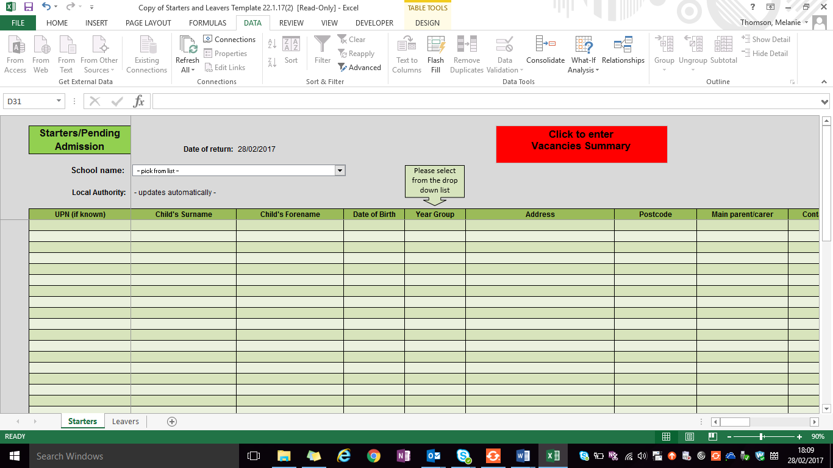

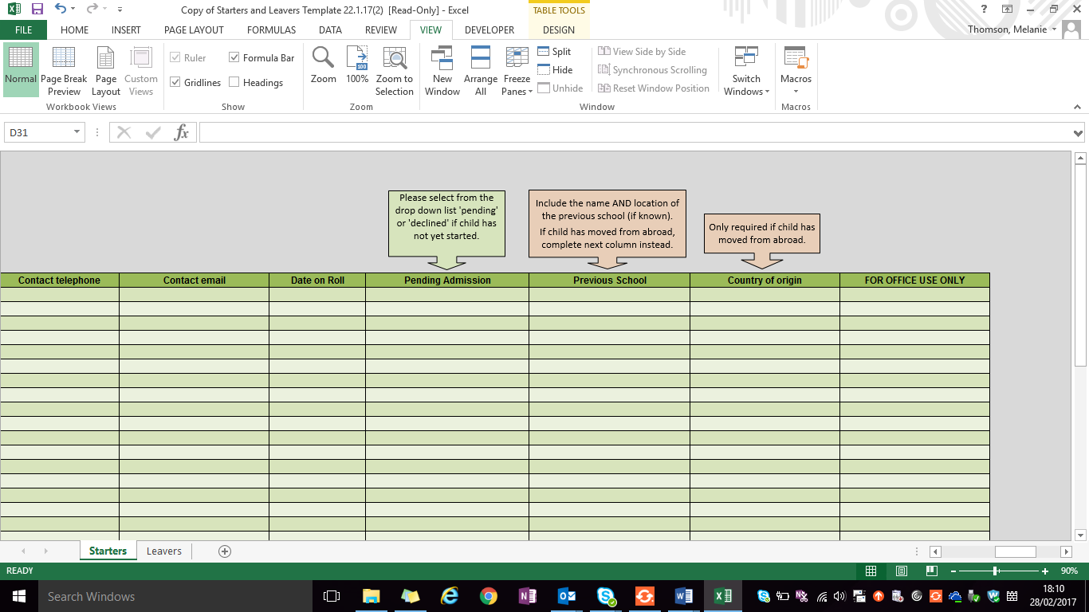

Please ensure that you also complete the ‘Vacancies Summary’ section of the Starters form:

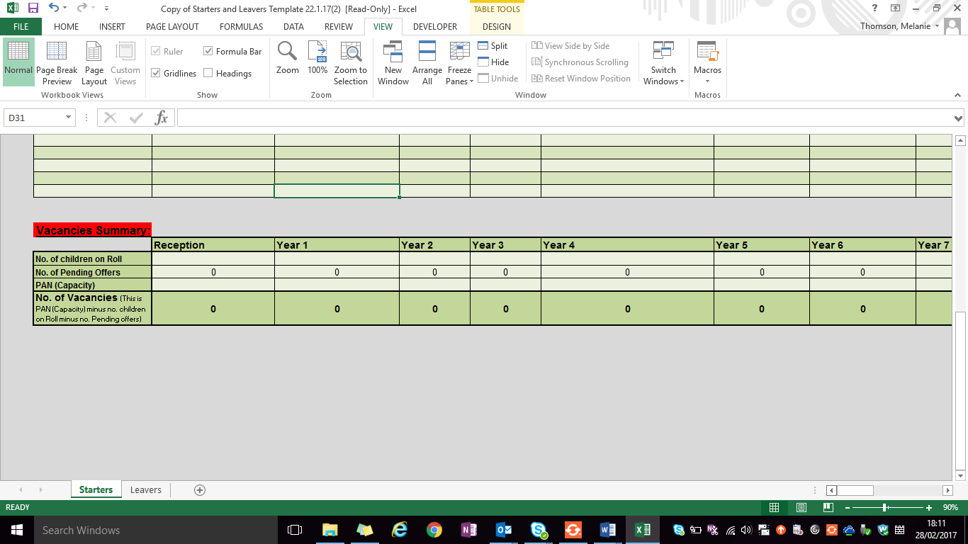
All schools will be required to provide the details as set out on the form for all new pupils they take on roll (for state schools this excludes reception and year 7).
Schools with an ELP must contact the School Admissions Team for a slightly amended version of the return.
Independent schools are asked to provide data for all their starters and leavers if school ends before Year 11. Reception and Year 7 starters should also be included to enable the LA to check against the data held by admissions to eliminate duplicate offers and to record where a child has taken up an Independent school but has failed to notify the LA.
Leavers
Snapshot of the leaver page
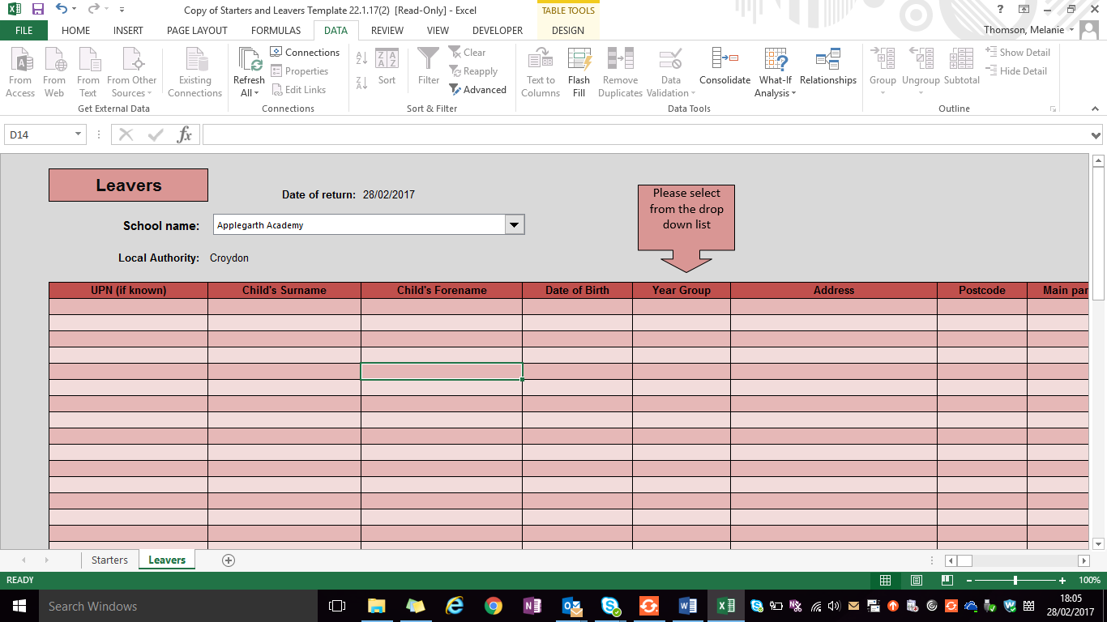

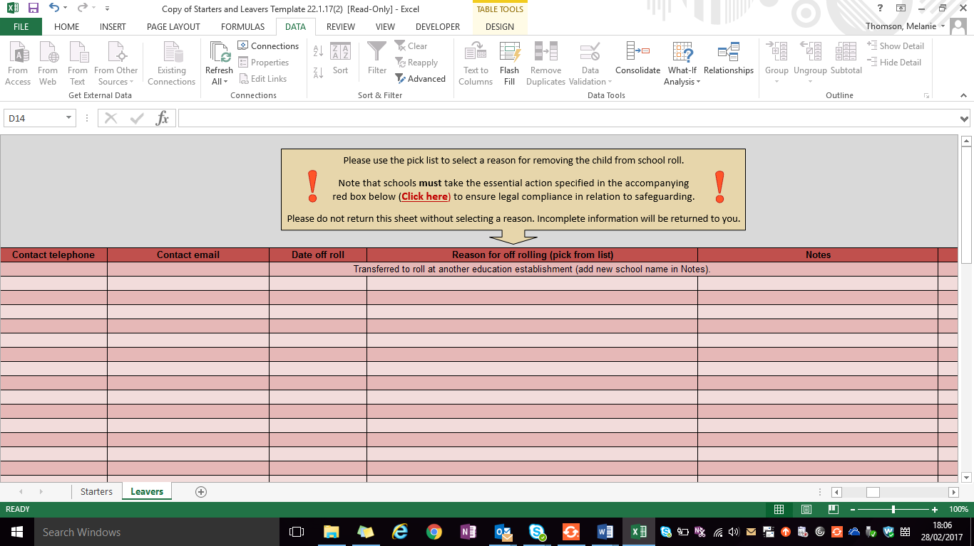
All schools will be required to provide the details as set out on the form for all pupils they take off roll (excluding children leaving at the end of year 11).
Independent schools are asked to provide leaver details for Year 6 and any other year group that their school provides education up to, if it ends before year 11.
A column must be completed for each pupil returned on this form. Schools cannot remove a child from their roll unless one of the grounds under regulation 8 of the ‘Education Pupil Registration Regulations’ for deleting a pupil from the admission register is met. These grounds can be found in the DfE’s CME statutory guidance.

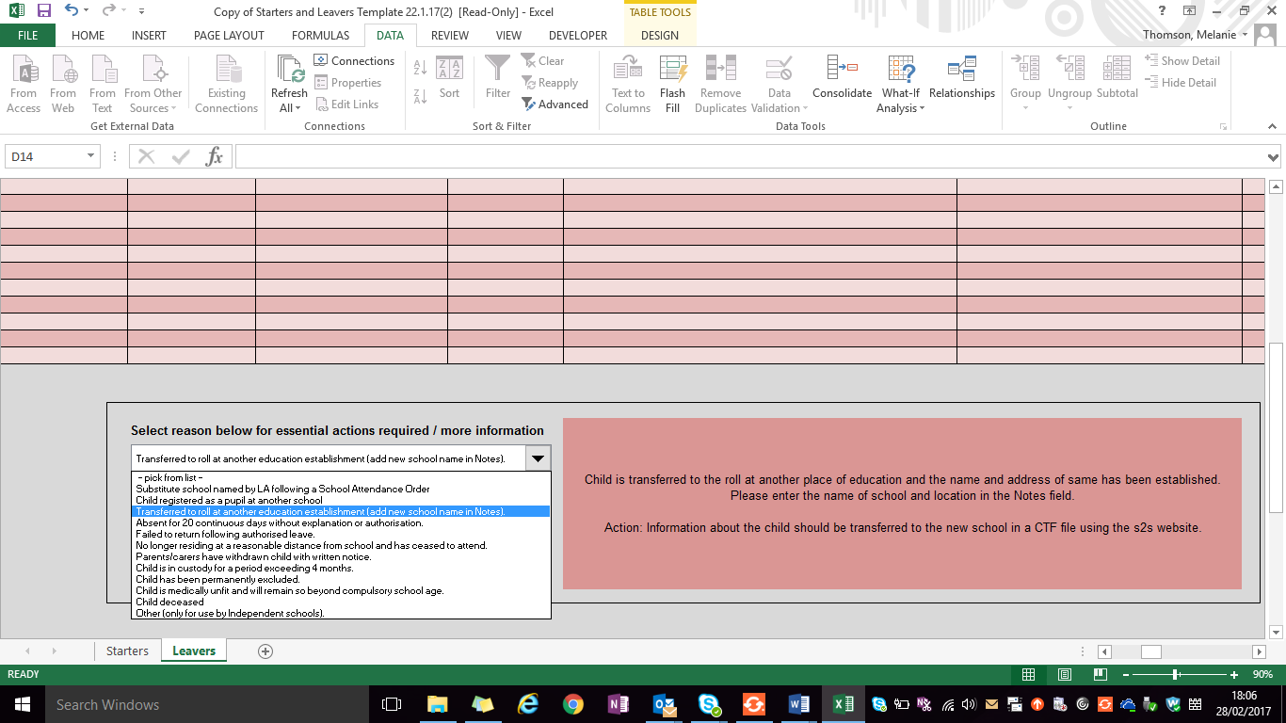

Appendix B: Children Missing from Education referral form

Notification of Child Missing from Education

Once completed, please email to childrenmissingfromeducation@croydon.gov.uk with any additional documents.

Your Designated Safeguarding Lead (DSL) should also be notified of this notification.

Child Details:
Child’s FORENAME:
Child’s SURNAME:
Ethnicity:
First Language:
Unique Pupil Number (UPN):
Date of Birth:
Gender:
Current Address:
New address (if known or applicable)
Parent/Carer (1) Name:
Parent/Carer (1) Address:
Telephone Number
Email Address
Parent/Carer (2) Name:
Parent/Carer (2) Address:
Telephone Number:
Email address:
Emergency Contact details provided in pupil registration:
GP Surgery:

Reason for Referral

Referrer Details:
Name of Agency/School:
Name of Referrer:
Referrer Position/Job Title:
Referrer Email Address:
Referrer Telephone Number:
Referral Date:
Last day of attendance:

Please provide information below regarding attempts to make contact with the family within the last 10 days: please note if these checks are not complete or evidence of attempts to gain information not provided your referral may be returned.

SCHOOL CHECK: | DATE(S) | OUTCOME | COMPLETED BY
Phone call – parent

Email to parent

Letter sent

Home visit made

Sibling schools contacted

Phone call - Emergency Contacts

New School, new address and travel information (if applicable)

Contact with other agencies involved with family

Contact with new boroughs Admissions Team. (If applicable)

Any other additional information relevant to this referral:

Where possible please submit a photo of the child and copies of identification available, e.g. passport, birth certificate via childrenmissingfromeducation@croydon.gov.uk

CME SAFEGUARDING CHECKLIST- Assessing a Child’s Vulnerability
Assessing vulnerability requires a combination of professional knowledge and experience of safeguarding and local circumstances. Agencies should follow their own safeguarding procedures and have regard to the London continuum of need:
http://croydonlcsb.org.uk/professionals/policies/#thresholds-amp-indicators-of-need
This guidance should be considered when a child is missing from education to ascertain their vulnerability and assist in the decision making process for making a referral.
 | YES | NO
Does the child have a formal child protection plan/child in need plan?

Is the child ‘looked after’ (LAC)?

Is there a history of domestic violence, parental mental health, parental substance or alcohol misuse?

Has there been adult’s or children’s criminal justice involvement in the past or at present?

Is this child mixing with known offenders?

Is there a good reason to believe that the child may be a victim of crime?

Is this child at risk of sexual exploitation? (please refer to CSE risk assessment)
Are there wider concerns about this child or their family with regards to possible radicalisation? (Please refer to PREVENT guidance)

Are there religious or cultural reasons to believe that the child is at risk?
- Rites of passage or forced marriage planned for the child
- Female genital mutilation
- Historical information relating to older siblings.
Does the child have any health requirements that place the child at risk?

Was the child noted to be depressed/self-harming prior to the unexplained absence?

Is there a person present in, or visiting the family that has convictions for an offence against a child?

Croydon Council will process any information shared in line with the provisions of the General Data Protection Regulation. Any personal information will be held in confidence and shared only where necessary. This data will be removed from council records after 25 years from the date of the child or young person’s date of birth. Under the General Data Protection Regulation, you have the right to make a formal request to the Council for access to personal data held about you or your child. Croydon Council has a duty under the Children’s Act 2004 to work with partners to provide and improve services to children and young people. Information provided will be shared with schools as necessary to arrange suitable provisions for your child. Croydon Council may also use this information for other legitimate purposes and may share this information where required with other bodies responsible for administering services to children and young people. To view our full Privacy Statement please visit: https://www.croydon.gov.uk/democracy/data-protection-freedom-information/privacy-notices/education-youth-engagement-service-privacy-notice

Appendix C: Notification of Permanent Exclusion

NOTIFICATION OF EXCLUSION FORM

Section 5 of The School Discipline (Pupil Exclusions and Reviews) (England) Regulations 2012 requires all state-funded schools, including academies and free schools, to notify the local authority of all permanent and fixed term exclusions.

PLEASE COMPLETE ALL RELEVANT SECTIONS OF THIS FORM
The completed form should be sent, along with a copy of the exclusion letter, to Croydon Council either by email to exclusions@croydon.gov.uk or by post to
Exclusion Notification, Croydon Council,
Floor 2 (Zone D), Bernard Wetherill House, 8 Mint Walk, Croydon, CR0 1EA
Name of school: | Tel: contact e-mail:
Pupil name: | First name Surname
Address:

Borough of residence: |  | Phone no. for family:
Date of birth: |  | Year group:
UPN |  | Gender:
SEN status:  - No SEND  - School Support  - EHCP | (Please also specify primary SEND need)
Ethnic origin: |  | Child looked after: Y/N
Free School Meals: | Y/N | Asylum Seeker: Y/N
Parent/carers name

Fixed term (no. of days) | Permanent: Y/N
Date exclusion commenced:
Date exclusion ended:
Total no. of days excluded this year:

Reason for Exclusion (Please tick of highlight):

- Physical assault against a pupil
Includes: fighting, violent behaviour, wounding, obstruction and jostling

- Physical assault against an adult
Includes: violent behaviour, wounding, obstruction and jostling

- Verbal abuse/threatening behaviour against a pupil
Includes: threatened violence, aggressive behaviour, swearing, homophobic abuse harassment, verbal intimidation,

- Verbal abuse/threatening behaviour against an adult
Includes: threatened violence, aggressive behaviour, swearing, homophobic abuse and harassment, verbal intimidation,

- Bullying
Includes: verbal, physical, homophobic bullying, racist bullying

- Racist abuse
Includes: racist taunting and harassment, derogatory racist statements, swearing that can be attributed to racist characteristics, racist bullying, racist graffiti

- Sexual misconduct
Includes: sexual abuse, sexual assault, sexual harassment, lewd behaviour, sexual bullying, sexual graffiti

- Drug and alcohol related incidents
Includes: possession of illegal drugs, inappropriate use of prescribed drugs, drug dealing, smoking alcohol abuse, substance abuse

- Damage
Includes: damage to school or personal property belonging to any member of the school community: vandalism, arson, and graffiti

- Theft
Includes: stealing school property, stealing personal property (pupil or adult), stealing from local shops, on a school outing

- Persistent disruptive behaviour
Includes challenging behaviour, disobedience, persistent violation of school rules

- Other
Includes: incidents which are not covered by the categories above but this category should be used sparingly

- Possession of an offensive weapon

Additional information required for Permanent Exclusions

Pupil Name:
Name of school contact:  Head of Year: | Tel: contact e-mail:  Tel: contact e-mail:
Previous schools:

Previous exclusions (permanent or fixed term)
Please give reasons
Is the pupil on the Child Protection register? Y/ N | Is the Pupil a Looked After Child? Y/ N  Does the pupil have free school meals? Y/ N
Does the pupil have a history of poor attendance? Y/N | Please give recent attendance
Relationships with peers | Relationships with staff
Summary of support received or other agencies/organisations involved with the pupil.
(please attach any PSP or IEP)
Reading age: | Spelling age:
CATS scores:  Verbal  Non verbal | SATS scores (indicate Key Stage)  English  Maths  Science
Strengths

Academic and Social
Attitude to Work
Parent/Carer

view on exclusion
Student

View on exclusion
Risk Assessment for placement at PRU
Depending on your response we may ask for a more comprehensive risk assessment

Are there any risks relating to:
AREA OF RISK | YES | NO | DON’T KNOW
Violence
Offending
Mental Health
Family & Relationships
Neglect
Alcohol & Drugs
Other (please specify)

Please provide any additional information.

Croydon Council will process any information shared in line with the provisions of the General Data Protection Regulation. Any personal information will be held in confidence and shared only where necessary. This data will be removed from council records after 25 years from the date of the child or young person’s date of birth. Under the General Data Protection Regulation, you have the right to make a formal request to the Council for access to personal data held about you or your child.

Croydon Council has a duty under the Children’s Act 2004 to work with partners to provide and improve services to children and young people. Information provided will be shared with schools as necessary to arrange suitable provisions for your child. Croydon Council may also use this information for other legitimate purposes and may share this information where required with other bodies responsible for administering services to children and young people.

To view our full Privacy Statement please visit:
https://www.croydon.gov.uk/democracy/data-protection-freedom-information/privacy-notices/education-youth-engagement-service-privacy-notice
Appendix D: Summary of school action when decision made to remove pupil from roll:
Statutory Ground for deletion from roll | School Action Required
Subsection (1) (a) LA amendment to existing School Attendance Order | Submit a Pupil Migration form
Subsection (1) (b) Pupil has transferred and been registered at another school | Submit a Pupil Migration form
Subsection (1) (c) Dual registration has come to an end | Submit a Pupil Migration form
Subsection (1) (d) the school has received written notification from the parent that the pupil is to be home educated | Submit a Children Missing Education referral and provide copy of written notification from parent. Pupil should remain on roll until confirmation is received from the LA’s Elective Home Education Monitoring and Support Teacher. Once confirmation is received a Pupil Migration form should be submitted.
Subsection (1) (e) Pupil no longer ordinarily resides at an address which is a reasonable distance from the school | Submit a Children Missing Education referral and provide copy of written notification from parent of new address. Pupil should remain on roll until confirmation is received from Children Missing Education Engagement Key Worker. Once confirmation is received a Pupil Migration form should be submitted
Subsection (1) (f) (i) (ii) (iii) Leave of absence exceeding 10 school days granted AND pupil has failed to return to school within 10 school days immediately following the expiry of the period for which leave of absence was granted | Submit a Children Missing Education referral and provide copy of any correspondence with parent re the period of leave. Pupil should remain on roll until confirmation is received from Children Missing Education Engagement Key Worker. Once confirmation is received a Pupil Migration form should be submitted
Subsection (1) (g) School medical officer has certified that pupil unlikely to be in fit state to attend school before ceasing to be of compulsory school age | Submit a Children Missing Education referral and provide copy of any correspondence relating to the illness. Pupil should remain on roll until confirmation is received from Children Missing Education Engagement Key Worker. Once confirmation is received a Pupil Migration form should be submitted
Subsection (1) (h) Child has not been located following 20 days unauthorised absence and reasonable enquiries have confirmed child no longer resides at given address | Submit a Children Missing Education referral and provide copy of any correspondence relating to any change of address and enquiries made by the school. Pupil should remain on roll until confirmation is received from Children Missing Education Engagement Key Worker. Once confirmation is received a Pupil Migration form should be submitted.
Subsection (1) (I) Pupil is detained for a period of not less than four months and the proprietor does not have reasonable grounds to believe the pupil will return at the end of that period | Submit a Children Missing Education referral and provide copy of any correspondence with the Youth Offending Service. Pupil should remain on roll until confirmation is received from Children Missing Education Officer. Once confirmation is received a Pupil Migration form should be submitted.
Subsection (1) (j) Pupil has died | Submit a Pupil Migration form
Subsection (1) (k) Pupil will cease to be of compulsory school age when the school next meets and school has been informed that pupil will cease to attend school | Submit a Pupil Migration form
Subsection (1) (l) Pupil has ceased to be a pupil at an Independent school | Submit a Statutory Notification of a Deletion from a Croydon School Roll
Subsection (1) (m) Pupil has been permanently excluded from school | Complete a notification of permanent exclusion to the LA. Once the permanent exclusion is ratified submit a Pupil Migration form.
Subsection (1) (n) Pupil was on roll during nursey education phase but has not transferred to a reception or higher class within the school | Submit a Pupil Migration form

Appendix E – Managed Moves: Good Practice Guidance

Introduction

  - Schools, parents and pupils have used a ‘fresh start’ in a new school as a formal or informal alternative to permanent exclusion for many years. A change of school can be particularly valuable if it is perceived that a pupil’s difficulties are the result of inappropriate peer relationships or if the relationship of trust between parent and school has broken down.

  - Best practice suggests that managed moves are planned between schools with the consent and co-operation of respective student’s parents/carers in collaboration with the Local Authority. Managed Moves are best used as part of the school’s early intervention strategies.

  - It is recommended that there is a clear protocol to govern the use of ‘managed moves’ as an alternative to permanent exclusion to ensure consistency of practice

  - It is the view of Croydon Council that ‘managed moves’ can be a useful tool to avoid permanent exclusion but that such moves must be carefully planned and implemented if the pupil’s difficulties are not to be exacerbated leaving the sending school with no option but to refer to the Primary Fair Access Panel.

  - Managed moves have been evidenced to be successful when schools and parents are transparent in their sharing of information.

  - This guidance does not apply to pupils moving in and out of PRUs. Such pupils will usually be subject to dual registration and the PRUs have their own guidance for schools on pupils who are accepted for respite at a PRU or who are being reintegrated to mainstream school.

  - When a pupil is ‘managed moved’ to a new school the new school should place the pupil on roll and take over full responsibility for that pupil. A managed move is a trial period at a new school and is undertaken with the agreement of all parties (including the parents/carers). All parties must be aware of what will happen if the managed move fails. The maximum time for this trial period is twelve weeks and fixed period needs to be set at initial meeting. Planned review meetings should be held with school and parent/carer at six weeks intervals.

If placement is agreed to be unsuccessful, pupils must return to their original school.

The school where the pupil was attending on the managed move should produce a report setting out the interventions and support put in place and the reasons it was unsuccessful.

  - Failure of a managed move should not automatically lead to Permanent
Exclusion. Schools should make their decisions re next steps at their discretion on an individual case by case basis.

- Good practice to be followed

  - The following is considered to be a step by step ‘good practice’ guide to ‘managed moves:

- Meeting at original school with parents/carers and pupil explores the option of a ‘fresh start’ at a new school. Pupil and parental preferences are sought and the realities of the situation discussed. Minutes of the meeting are kept on pupil’s file. It may be appropriate to invite other adults who have been involved with the pupil to this meeting.

- Managed Moves for students with Statements of Special Educational Needs or Educational Health and Care Plans need to be referred to the SEN team.

- In respect to Looked after Children the child’s social workers; carer and the Virtual School must be notified of any managed move.

- The Head teacher makes contact with the ‘new school’, discusses the pupil and secures school’s agreement to the transfer in principle. In some cases it might be appropriate for another professional to make the initial approach.

- The Learning Access team can assist head teachers with identifying schools with vacancies in the appropriate year group if needed.

- Parents are requested to complete the LA School transfer form.

- The original school sends paperwork to the new school including (as a
minimum):
- the pupil’s attendance records
- conduct log
- copies of any IEPs or PSPs
- current academic attainment data.
- any medical needs
- Details of child protection and safeguarding information should be shared, in the appropriate manner, with the receiving school only once managed move has been agreed between all parties.

- As deemed appropriate a risk assessment could be completed by the sending school and sent to receiving school as part of initial information sharing process.

- The new school meets with the parents and pupils. At this meeting as well as the expectations of the new school and general arrangements for transfer and induction (e.g. uniform requirements, times of school day etc) the pupil’s support needs should be discussed. Individual support plan is devised by the school in consultation with parent/carer and young person. A start date should also be agreed. This should be no later than two weeks after the meeting.

- The pupil’s progress should be reviewed with parents after the first two weeks and then half termly until the pupil is considered well settled. If placement is agreed to be unsuccessful, return to original school is supplemented by a full report.

- The transfer is agreed and the school notifies the Learning Access Team.

- The pupil is dual registered for the period of the managed move and can only be ended when confirmation of a successful move is received from the new school.

- The pupil is offered a start date and the full record is transferred from the original to the receiving school. This must include all records relating to Child Protection/safeguarding concerns which may have been held separately from the child’s main school record. These should be transferred within three weeks from the date of the approach.

  - Evidence from this and neighbouring LAs suggests that if the move is not properly planned and in particular if parental or pupil wishes have not been fully considered then the ‘managed move’ is not likely to be successful. It is essential that the transferring pupil should be well supported by the new school during the transition period. This should include as a minimum entitlement:
- access to a named adult with whom the pupil/parent can share anxieties and concerns;
- access to a specialist behaviour mentor or teacher in order to address behaviour concerns and peer support through a buddy or mentoring scheme.(More detail is given in 4 below)

- Support for pupils

  - The following could be considered as support for transferring pupils. The list is not exhaustive and the support can be ‘mixed and matched’ in order to provide an appropriate individualised package:
- Access to the SENCO or specialist SEN teacher for baseline testing and needs assessment
- Specialist SEN teaching support
- Learning or Behaviour Mentor individual support
- Access to the school’s assigned Educational Psychologist
- Access to small group support in eg Social skills or anger management
- Access to a counsellor
- TA support
- LSU support/Pastoral Support
- Peer support – e.g. a buddy
- In school support procedures such as report cards, access to a named teacher, etc.
- A mentor from the voluntary or community sector
- Access to after school clubs and activities
- Learning mentor from virtual school if appropriate (LAC only)

- Funding

  - When a pupil is subject of a ‘managed move’ during the financial year it is for schools to agree what, if any, funds will be transferred to the new school to support the managed move. AWPU is automatically corrected for the Autumn and Spring terms and it would seem reasonable to transfer the remaining portion of the AWPU from the original school to the new school along with an Pupil Premium Grant (PPG). This would mirror the DfE requirements for funding arrangements concerning permanently excluded pupils.

Funding to support pupils with a statement of SEND/EHCP will automatically be transferred to the receiving school with effect from the date of transfer provided that SEND is informed. Schools can also make use of delegated SEN funding to purchase additional support for pupils.

  - The receiving school should consider using ‘in-house’ support for example learning or behaviour mentors, LSUs etc.

- Practice to be avoided

  - Advising parents to remove their child from roll and ‘find another school’. In practice this often results in the child being out of school for a considerable period of time.
  - Advising parents to remove their child from roll and ‘Electively Home Education’. In practice unless parents are seeking to ‘educate otherwise’ for philosophical, ideological or religious reasons the education provided is rarely ‘suitable or efficient’. This may also place the pupil at additional safeguarding risks.
  - Transferring children without adequate induction or support.
  - Providing receiving school with insufficient information and/or unrealistic picture of student’s strengths, difficulties or needs. This practice could result in negative impact on the child.

Other professionals who may be involved with pupils and their parents/carers who could be involved at any stage during the ‘managed move’ process:
- SENCO
- Mentor or Teaching Assistant
- Assigned Educational Psychologist

Member of the Virtual School (if looked after)

Support teacher
- Education Welfare Officer
- Social Worker

MANAGED MOVE NOTIFICATION FORM

PART A – to be completed by original school

Name of Pupil Date of Birth NCY

School: Ethnic Origin:

Date of admission to current school

Previous schools

LAC Yes/No SEN status

Other agency involvement

% Attendance last term Punctuality

No & length of fixed term exclusions in last year

Any internal or external arrangements made in addition to or as an alternative to exclusion

Reason(s) for Managed Move

Proposed new school

‘Trial’ period agreed Yes/ No Length of ‘trial’ (no longer than 1 term)

Arrangements if ‘trial’ unsuccessful

Date of meeting with parent to agree managed move

Signed: Headteacher………………………………………………..

Parent/Carer………………………………………………..

Pupil…………………………………………………………

PART B – to be completed by new school

School Name:

Date of Interview at new school

Start date at new school Trial period Yes/No

Induction arrangements:

Arrangements if ‘trial’ unsuccessful

Signed: ………………………………………….. Headteacher

PLEASE SEND TO: fairaccess@croydon.gov.uk

Appendix F – Pupil leavers form

Pupil Leavers form

Dear Parent

Please complete this form and attach any addition information.
Child’s Name: | Parent’s Name:
DOB: | DOB:
Year Group: | Telephone Number:  Email address:
Your full new address: | New school Name and Address (if known):
The last day your child will be attending school:

The reason why your child is leaving

MOST IMPORTANTLY, PLEASE ATTACH A COPY OF YOUR FLIGHT DETAILS:

Thank you

Advice letter from, Her Majesty’s Chief Inspector, on the latest position with schools in Birmingham and Tower Hamlets to Secretary of State for Education, July 2015.

